Housing Delivery Action Plan March 2020
Contents
Introduction 2
Housing Delivery in Gravesham 5
Planning context 5
Local planning context including local plan status and approach to growth 5
Ebbsfleet Development Corporation 7
Housing Delivery Test Measurement and Five Year Land Supply 8
Land Supply to 2036 9
1. Gravesham Borough Council as a Local Planning Authority 13
2. Gravesham Borough Council as a landowner and landlord 15
3. Gravesham Borough Council’s wider role 16
4. Gravesham Borough Council as a partner 17
5. Supply side issues 17
6. Demand side issues 20
7. Infrastructure and Public Services Provision 21
Conclusion 22
Appendix A: Work Programme 23

Introduction
It is widely accepted that we are experiencing a national housing crisis. The lack of supply and pressure for new homes is felt most acutely in the South East of England, where demand is such that households are having to put ever greater shares of their income into housing costs. This is illustrated by ONS data, see Figure 1 and Figure 2, which illustrate the growing disparity between property prices and earnings. As time has progressed, greater multiples of income are required to meet housing costs illustrating that affordability in the South East is worsening, as well as in Gravesham. One of the main reasons for property prices increasing is due to supply being unable to keep pace with demand.
Figure 1: ONS House Price Statistics for England and Wales 2011
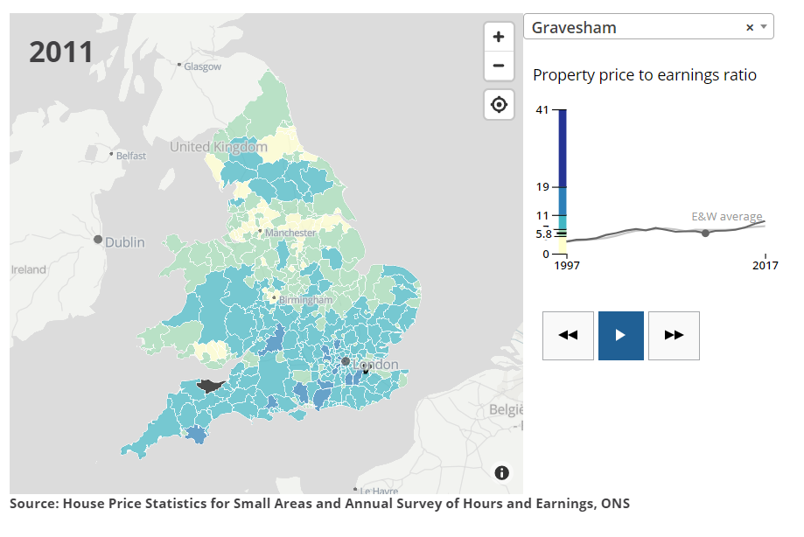
Figure 2: ONS House Price Statistics for England and Wales 2019
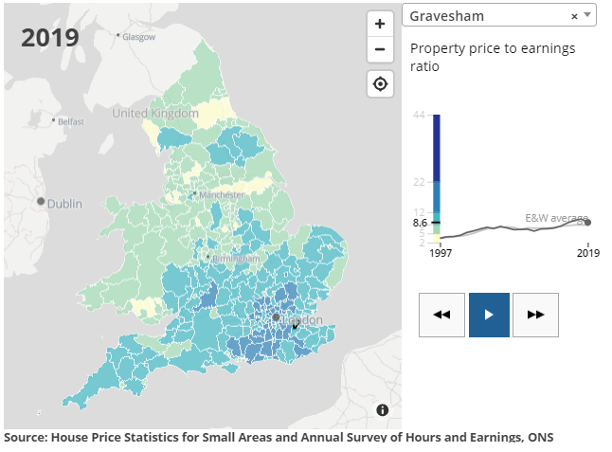
Successive Governments have recognised insufficient housing supply as a key issue facing the country, the current Government published its white paper on the issue, “Fixing our broken housing market” in February 2017. As part of the white paper, the then Prime Minister made it clear that her Government wanted more homes built to slow the rise in house prices so that more families can afford to buy a home and to also bring down the cost of renting.
This objective to increase the number of new homes, is reflected in the revised National Planning Policy Framework (NPPF February 2019). The Housing Delivery Test was introduced as part of the revisions to the NPPF in 2018, with subsequent changes to Planning Practice Guidance in December 2020 and the standard method for assessing local housing need, to plan for the delivery of 300,000 new homes a year and plan for more homes in the right places. As illustrated in Figure 3 the supply of homes in England has consistently been below the range of estimated need.
Figure 3: Net housing supply and estimated homes needed (England)
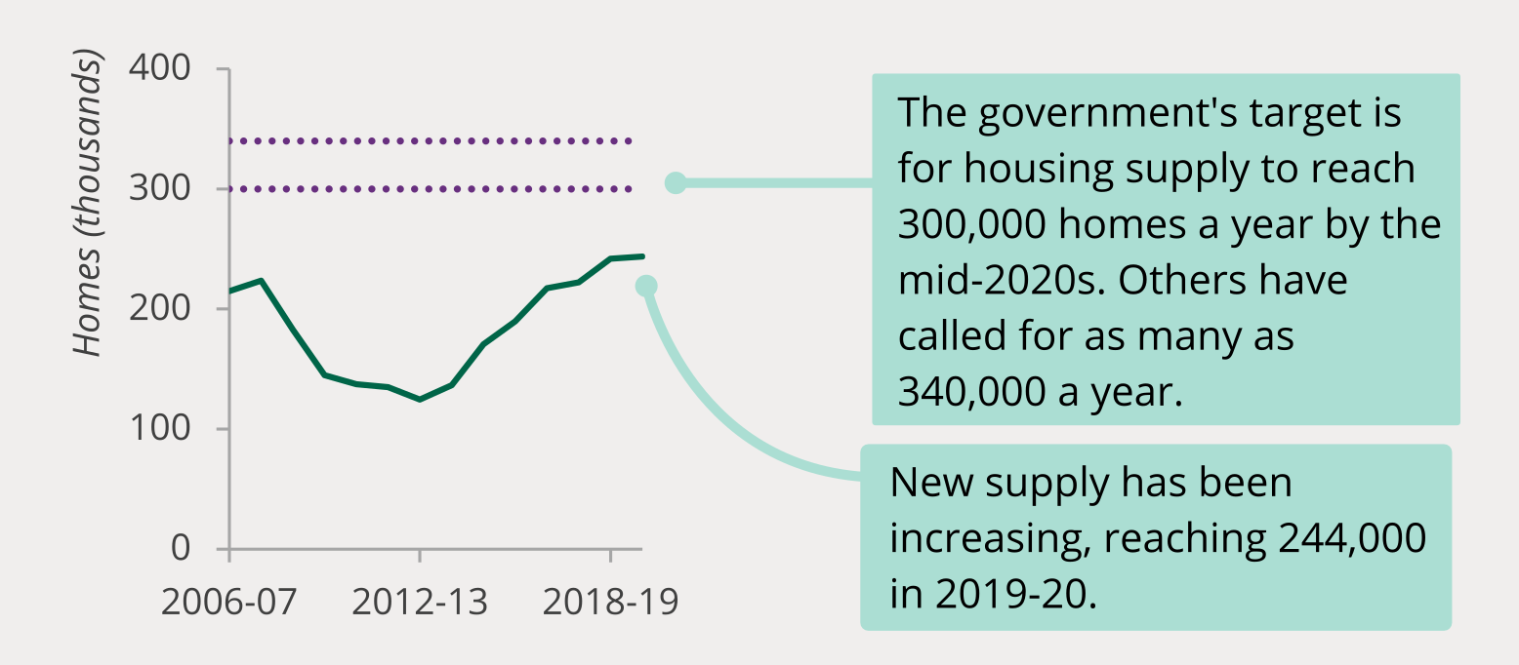
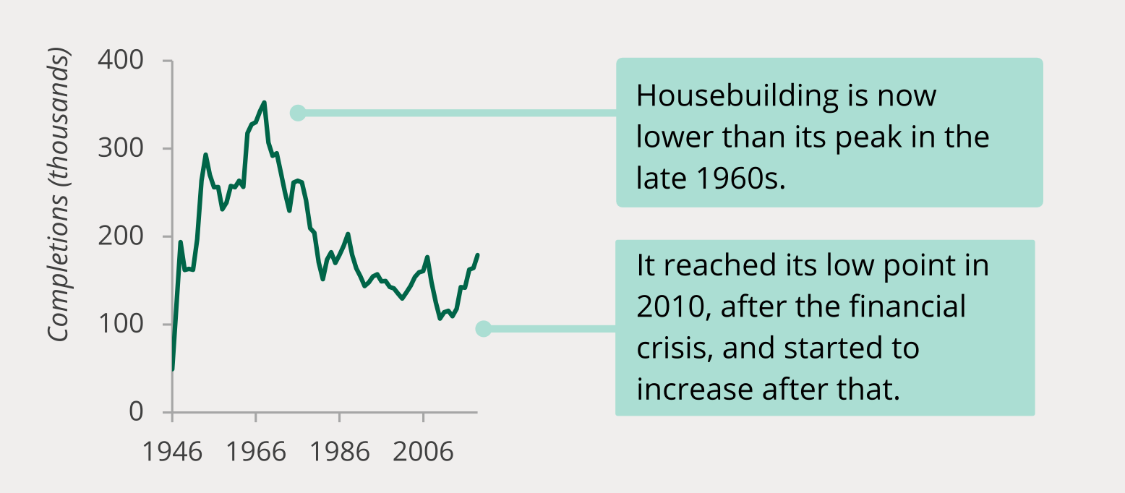
Sources: House of Commons Library, Tackling the under-supply of housing in England (01/21).
The National Planning Policy Framework (NPPF) requires local planning authorities to maintain a supply of deliverable sites sufficient to provide 5 years’ worth of housing against their housing requirement. A Housing Delivery Test (HDT), measures net additional dwellings provided in a local planning authority area against the houses required. The consequences of failing the HDT are set out in the NPPF as being:
“Where the Housing Delivery Test indicates that delivery has fallen below 95% of the local planning authority’s housing requirement over the previous three years, the authority should prepare an action plan in line with national planning guidance, to assess the causes of under delivery and identify actions to increase delivery in future years… (in addition) Local planning authorities should identify and update annually a supply of specific deliverable sites sufficient to provide a minimum of five years’ worth of housing against their housing requirement set out in adopted strategic policies, or against their local housing need where the strategic policies are more than five years old. The supply of specific deliverable sites should in addition include a buffer (moved forward from later in the plan period) of:
a) 5% to ensure choice and competition in the market for land; or
b) 10% where the local planning authority wishes to demonstrate a five year supply of deliverable sites through an annual position statement or recently adopted plan, to account for any fluctuations in the market during that year; or
c) 20% where there has been significant under delivery of housing over the previous three years, to improve the prospect of achieving the planned supply.. [From November 2018, this will be measured against the Housing Delivery Test, where this indicates that delivery was below 85% of the housing requirement.]”
All local planning authorities with a result of less than 95% of the delivery rate measured against housing completions for the preceding three years have six months to prepare an Action Plan. The Housing Delivery Test Result for Gravesham Borough Council was published by MHCLG on 19 January 2021. Gravesham Borough Council’s 2020 measurement is 70%. This means that the Council has to apply:
- the presumption in favour of sustainable development in decision making of planning applications for residential development;
- a 20% buffer to its housing need as set out in the 5 year land supply statement;
- produce a Housing Delivery Action Plan.
The Action Plan is described in Planning Practice Guidance as being:
“A document produced by the local planning authority to reflect challenges and identify actions to address under-delivery against the housing requirement in the area. The document’s purpose is to detail the reasons for under-delivery and the steps the authority intends to take in mitigation and drive up delivery in the area. A good action plan will identify ways to reduce the risk of further under-delivery and set out the case for measures to maintain or improve levels of delivery.”
By preparing an Action Plan, the Council is positively responding to the challenge of increasing its housing delivery. The Action Plan is intended to be a focussed document that identifies practical measures for improving local housing delivery and is informed by local evidence and research of key issues. Much of this local evidence and research will be published as part of the Council’s Authority Monitoring Report.

Housing Delivery in Gravesham

Planning context

Local planning context including local plan status and approach to growth
The Development Plan for Gravesham consists of:
- Gravesham Local Plan Core Strategy (September 2014)
- Saved policies from the Gravesham Local Plan First Review (GLP 1st Review – adopted November 1994)
- Kent Minerals and Waste Local Plan 2013-2030 (adopted by Kent Country Council in July 2016) and the Early Partial Review adopted September 2020
- South East Marine Plan
Strategic guidance related to how much residential development should be planned for was previously set out in the Gravesham Local Plan Core Strategy. The Core Strategy sets out the Council’s long-term spatial vision for the Borough, the plan period extends from April 2011 to March 2028. The Borough’s housing requirement for this period is identified as being for at least 6,170 homes, the Core Strategy also identifies the areas where major change is expected to take place and allocates Key Sites for development. Monitoring data from the Authority Monitoring Reports and Borough’s Five Year Land Supply Statements, clearly shows that since 1st April 2011, the Borough has only met or exceeded the number of homes needed on one occasion (2012-2013), see Figure 4.

Figure 4: Net dwellings completed in Gravesham 2011-2020
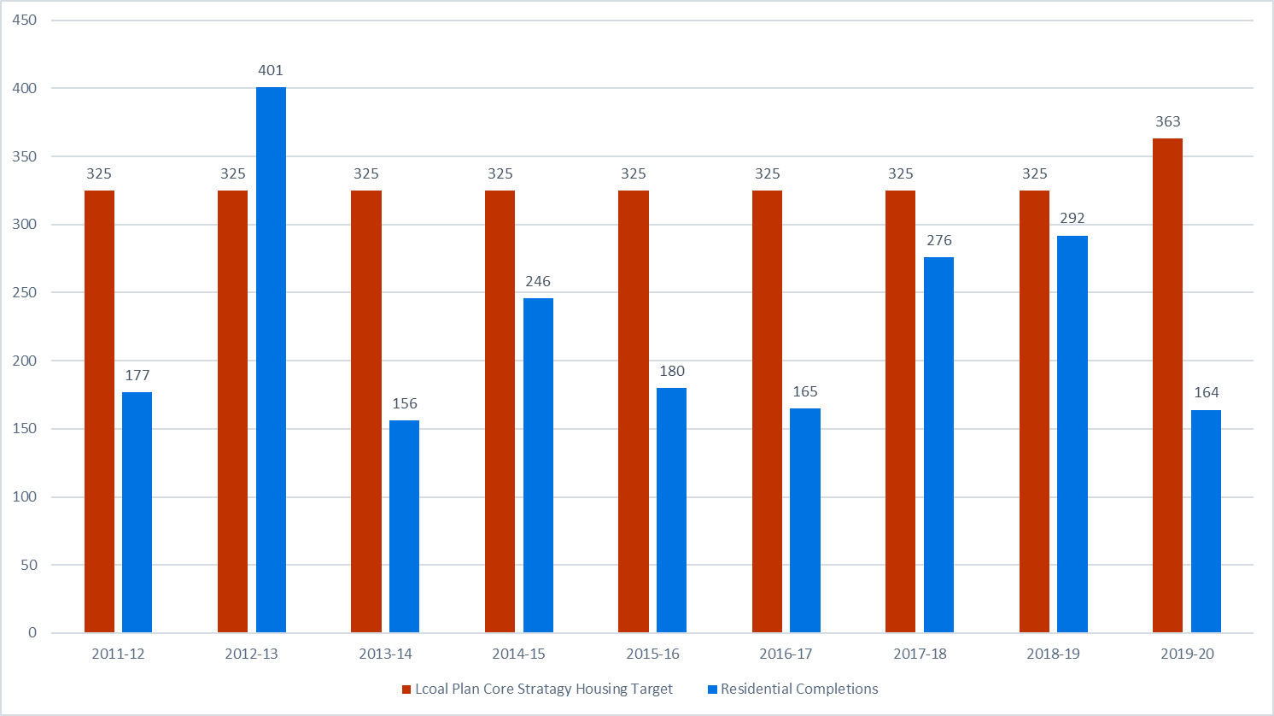
The Local Plan Core Strategy prioritises development in the urban area as a sustainable location for development, to be achieved by:
- Promoting regeneration by prioritising the redevelopment and recycling of underused, derelict and previously developed land in the urban area. This will be principally through redevelopment of former industrial sites in the opportunity areas of Northfleet Embankment and Swanscombe Peninsula East and Gravesham Riverside East and North East Gravesend to create new residential neighbourhoods and employment areas;
- The continued development of a new, sustainable, mixed-use community in the Ebbsfleet (Gravesham) Opportunity Area, which will include the provision of high quality employment floorspace;
- Revitalising the Gravesend Town Centre Opportunity Area as a focal point for retail, leisure, cultural and tourism facilities and small scale office provision to serve the needs of the Borough whilst preserving and enhancing its character as a riverside heritage town; and
- Bringing forward a range of suitable sites in other parts of the urban area for residential and employment development, including land at the Coldharbour Road Key Site.
In the rural area, development is supported within rural settlements inset from the Green Belt. Outside of those settlements development, including that for affordable housing and proposals to maintain and diversify the rural economy is supported where it is compatible with the Core Strategy and National Planning Policy Framework.
The adopted Core Strategy includes a proposal to undertake a Green Belt boundary review to identify additional land to meet the housing needs of the Borough and to safeguard land to meet development needs beyond the plan period whilst maintaining national and local planning purposes of the Green Belt. This piece of work forms part of the emerging Local Plan which was consulted upon during October-December 2020. As set out in the Part 1: Local Plan Core Strategy Partial Review and Site Allocations consultation document, there is a need for some 10,480 dwellings in the Borough between 2020-2036, at an annual rate of 655 dwellings per annum. As set out in the Borough’s current 5 year land supply statement, the Council can only demonstrate a supply of 2,574 dwellings between 2020-2025, which is equivalent to 3.27 years of need, which for the 5 year land supply period is 3,930 dwellings (with a 20% buffer applied).

Ebbsfleet Development Corporation
The Government recognised the significant growth challenge in North Kent and determined that a dedicated resource with significant financial support was needed. The Ebbsfleet Development Corporation was formed in early 2015 and took over responsibility for making decisions on planning applications in some parts of the Borough on 1 July 2015, see Ebbsfleet Development Corporation website.
The Government’s explanation of the Ebbsfleet Development Corporation is:
To speed up delivery of up homes and jobs in North Kent through the creation of a 21st century garden city in North Kent. The stated aim of the EDC is to deliver up to 15,000 homes and 30,000 new jobs through working with local authorities and local communities to develop a shared vision for the area, providing high quality, attractive and sustainably-constructed housing as well as opportunities to live and work. The EDC are also taking forward a core infrastructure investment programme that will deliver gas and electricity networks, telecoms, water services and the highways people need.

The Ebbsfleet Development Corporation have recently purchased the land which constitutes Ebbsfleet Central (an area that falls within Dartford and Gravesham) and are currently preparing a masterplan to bring forward a mixed use development. In addition to this, the Ebbsfleet Development Corporation are investigating opportunities for development in Northfleet through the reconfiguration of Blue Lake and the Northfleet Waste Water Treatment Works.

Housing Delivery Test Measurement and Five Year Land Supply
The Housing Delivery Test Measurement as published by MHCLG shows that over the preceding three years 1st April 2017 – 31st March 2020 only 70% of the dwellings needed in the Borough as set out in the Local Plan Core Strategy were delivered, this is illustrated by Figure 5.
Figure 5: Dwellings supplied 2017–2020 compared with the Local Plan Core Strategy Dwelling Requirement for 2017-2020.

As stated previously, the Borough’s most recent 5 Year Land Supply Statement for 1st April 2020 – 31st March 2025 identifies a requirement to plan for 3,275 dwellings without a buffer, and 3,930 homes with a 20% buffer applied as required by the National Planning Policy Framework. Against this requirement the current identified land supply is only capable of delivering 2,574 homes, i.e. against a 5 year land supply requirement, the Council is only able to demonstrate a 3.27 year land supply, see Figure 6.
Figure 6: Five Year Land Supply – 1st April 2020 – 31st March 2025

Land Supply to 2036
The 2020 Draft Strategic Housing Land Availability Assessment (SHLAA) identified 118 sites which benefit from planning permission, are allocated in the Local Plan Core Strategy (2014) or are brownfield sites within the Urban Area, which are capable of delivering housing between 2020-2036. These sites are identified as having the potential to deliver 7,506 homes. The vast majority of these are expected to come forward from sites within the urban area, with only a limited number expected to come forward from the rural area.
The draft SHLAA estimates that 796 windfall dwellings will come forward in the Borough between 2020-2036, 396 windfall dwellings on small windfall sites and 400 on large windfall sites. The draft SHLAA contains a number of greenfield and Green Belt sites that have been identified as having the potential to deliver housing, subject to them formally being identified as a site allocations, subject to Development Plan and National Planning Policy Framework constraints being relaxed. As such these sites are not considered to currently form part of the Borough’s land supply.
An analysis of the size of sites which contribute to the anticipated future housing supply from 1 April 2020 to 31 March 2036 as set out above is illustrated in Figure 7, Figure 8 and Figure 9. It shows that 97.7% of dwellings are on major development sites, which are defined by the NPPF as having a capacity of ten or more dwellings. 91.7% are on sites with a capacity of 100 dwellings or more. Only 2% of dwellings are on small sites of between 1 and 9 dwellings.
Figure 7: 2020 Land Supply – Number of sites by scale of site in terms of dwellings 2020-2036

Figure 8: 2020 Land Supply - Number of Dwellings by scale of site in terms of dwellings 2020-2036

Figure 9: 2020 Land Supply – Percentage of dwellings coming forward by scale of site in terms of dwellings 2020-2036

What are we going to do to ensure more homes are built within Gravesham?
The Council has a number of responsibilities, many of which can directly influence how many homes are built locally, as illustrated in Figure 10.
Figure 10: Understanding the Council’s role and key factors influencing and driving low rates of housing delivery.
1. GRAVESHAM BOROUGH COUNCIL AS A LOCAL PLANNING AUTHORITY
2. GRAVESHAM BOROUGH COUNCIL AS A LANDOWNER & LANDLORD
3. GRAVESHAM BOROUGH COUNCIL WIDER ROLE
4. GRAVESHAM BOROUGH COUNCIL AS A PARTNER
5. SUPPLY SIDE
6. DEMAND SIDE
7. Infrastructure and Public Services Provision

1. Gravesham Borough Council as a Local Planning Authority
The Borough Council is the plan making authority for Gravesham, however in terms of decision taking for planning applications the responsibility is split between the Council and Ebbsfleet Development Corporation. View the area Ebbsfleet Development Corporation is responsible for which also includes parts of Dartford Borough.
In terms of plan making, the Borough Council is progressing work on an emerging Local Plan, which includes a Partial Review of the Local Plan Core Strategy Partial Review, Site Allocations and a Development Management Policies Document. This will contribute towards boosting local housing delivery by providing a greater mix of sites to assist developers in delivering the right sizes, types, and tenure of homes in the Borough.
Current Local Plan Core Strategy policies being reviewed that will assist in boosting housing and economic development in the Borough include:
- Policy CS02: Scale and Distribution of Development
- Policy CS07: Economy, Employment and Skills
- Policy CS08: Retail, Leisure, and the Hierarchy of Centres
The Council’s Planning Policy team is working proactively with stakeholders such as the local community, developers, and partners to ensure that this work is completed by 2021 and submitted to the Planning Inspectorate for examination.
As part of the evidence that underpins Local Plan monitoring and the evidence needed to support the Local Plan Core Strategy partial review, the Council monitors when development is implemented and when it is completed. This data has shown that, at times, there is a significant lag between when permission is granted and when development begins on site. This is a very important factor to understand and counter. To address these issues the Council has set up a ‘Development Sites Implementation Group’, the objective of this group is to identify any barriers to delivery and to work with developers, landowners and other departments within the Council to overcome barriers that may exist to bring sites forward for development.
One of the key pieces of evidence being undertaken to underpin the Local Plan Core Strategy partial review and the Site Allocations and Development Management Policies document going forward, is a Strategic Housing Land Availability Assessment (SHLAA). This SHLAA will identify the potential for intensification of the density of development, identify additional possible development sites within the Borough and assist the Council in promoting these for development. It will also assist the Council in improving our understanding why development on some sites, such as sites allocated within the Local Plan Core Strategy, has been slow to come forward.
The responsibility for effective decision taking in terms of Development Management is split within the Borough as advised earlier and whilst the Borough Council works effectively with colleagues in the Ebbsfleet Development Corporation, this Action Plan does not cover the Corporation. In terms of Development Management, Planning Agents, Developers and Landowners have raised concerns regarding the length of time it can take for decisions to be made. The speed of decision taking is influenced by a number of factors, these include the quality of applications received by the Council, resources available internally, performance of IT infrastructure and software, effectiveness of officers, etc. A number of actions have been undertaken internally to improve performance and this is reflected in the improving feedback received and demonstrated through the backlog of applications reducing.
However, the Council is acutely aware that more can be done in this area. Some of the actions currently being undertaken to improve the service further include:
- Developing a local validation list (Completed)
- Developing an accredited agent scheme to foster good working relations between the council and planning agents and to promote the quality planning submissions (to be progressed).
- Continually reviewing the use of planning conditions to ensure:
  - Number of conditions used is minimised (at same time recognising that very often conditions are imposed due to a reluctance from developers to submit information prior to a planning application being determined, because the submission of information will be a cost to the developer with no guarantee that permission will be granted)
  - Use of pre-commencement conditions is reduced,
  - Delays in processing discharge applications is minimised, and
  - Producing standard list of planning conditions which are transparent to applicants, agents, Members and public
- Making the Planning Obligations process more transparent, the Council has published an Infrastructure Funding Statement and will bring forward a Supplementary Planning Document to assist when resources allow
- Keeping the backlog of applications to a minimum – it is recognised that due to unforeseen difficulties there may always be some applications that are not dealt with within the set or agreed time limits (ongoing)
- Improve information disseminated through the Council’s website (ongoing)
- Investigating whether text message updates used for licensing can be extended to planning applications – multiple benefits to customer and the Council (to be progressed).
- Addressing data quality within and functioning of the current planning system used by the Council (ongoing)
- Maintaining a fully resourced and skilled workforce (ongoing)
- Having a realistic and flexible approach to tenure mix to accelerate delivery (continued improvement is sought through a number of avenues)
Examples of measures already taken in terms of Development Management include:
- Investment in Information Communication Technology
  - much of the planning application process is paperless. Multiple benefits for Council and the environment
  - flexible working enabled and enhanced to enable home working as a result of Covid-19, please see the Strategic Environment Cabinet Portfolio Impact report taken to Strategic Environment Cabinet Committee in June 2020
  - devices can be taken on site to enable pictures to be taken and plans to be checked without need for paper
- Introduced Planning Performance Agreements to direct and tailor resources for determining potentially more complex applications, covering all aspects of the planning process from the pre-application stage to the discharging of conditions.
- A re-freshed pre-application advice service which explicitly advises the resource to be provided for each service level. Includes addition of concept pre-application advice when the principle of a particular type or form of development is proposed.
- Make greater use of the Design Review Panel, which calls on industry experts to provide high quality design advice to developers
- Reduced need for delegated reports – follow focused report style, which had been highlighted as best practice, so that reasons for permission are included on householder applications that are permitted under delegated powers
- Introduction of a Local Validation List and the adoption of additional Supplementary Planning Documents.
The Council’s planning function also includes planning enforcement, which deals with breaches of planning controls, including where building work requiring planning permission is undertaken without such permission, where conditions attached to a planning condition are not complied with, or where the use of a building or site is changed without planning permission. Under Section 94 Town and Country Planning Act 1990, the Council can issue a completion notice requiring a developer to complete a development if the granted permission has been lawfully implemented and the uncompleted development is harmful to the amenity of neighbours. Failure to complete a development, when a completion notice has been issued results in withdrawal of the planning permission in respect of any further part of the development.
There are conditions to the exercise of the power which are set out in Sections 94 and 95 Town and Country Planning Act 1990:
- The Council must be satisfied that the development is not likely to be completed within a reasonable period.
- The developer must be given a period of at least 12 months to complete the development.
- The completion notice must be signed off by the Secretary of State, and there is an appeal process which applies before the notice can be signed off.
- Notice must be given to the landowner, the occupier and anyone else whom the Council thinks will be affected by the notice.
A completion notice cannot be used to force a developer to implement a planning permission, nor can it force a developer to complete the development, if not complied with, planning permission is simply removed from the uncompleted part of the development.

2. Gravesham Borough Council as a landowner and landlord
Gravesham Borough Council has limited land assets, the Council’s main land holdings outside of its housing stock are primarily focused in and around Gravesend town centre. The Council is actively working on bringing forward development at The Charter and St Georges Phase 2 (formerly known as Heritage Quarter) and at the former Lord Street Car Park. Alongside these immediate schemes, the Council is working on bringing forward development on Parrock Street Car Park, the Wickes site and the current Civic Centre site. The Council has successfully delivered affordable homes on a number of smaller sites within the Borough. Work is being undertaken by the Council’s Housing Strategy and Development team to bring forward affordable housing at a number of sites including:
- St Hilda’s (planning application reference 20170737, completed and occupied. Known as Pankhurst Place)
- St Patricks Gardens (planning application reference 20190503)
- Valley Drive (planning application reference 20190155)
- Whitehill Lane (planning application reference 20171385)
- Former St John’s Ambulance Hall (planning application reference 20200561)
- Constable Road (planning application reference 20190833)
The Council is also exploring opportunities that maybe available to increase housebuilding rates through partnership working or other delivery vehicles and to this end the Council has formed a Local Authority Trading Company (LATCo) known as Rosherville Limited. One of the initial tasks of Rosherville Limited is to work with Reef Group to bring forward the recently permitted development known as ‘The Charter’.
The Council also proactively works with other public sector landowners in Gravesham including Kent County Council, Ebbsfleet Development Corporation, and Homes England. Whilst it should be noted that different organisations have different approaches to their land assets and potential disposal strategies, the Council has worked proactively with the Ebbsfleet Development Corporation to bring forward proposals for Milton Place which should deliver 100 dwellings.
As a stock owning authority, some of the Council’s most extensive land assets are located in Council estates. Where opportunities arise for redevelopment or intensification the Council considers these and the benefits and the benefits that this will bring to new and existing residents. At present, the Council is investigating what further opportunities may exist within its existing portfolio of sites.

3. Gravesham Borough Council’s wider role
The Council recognises that it has a significant role in bringing forward growth in the Borough, this is not limited to just housing but also encompasses commercial and leisure floor space. The Council will seek to build upon work that has already been undertaken by prioritising its own and seeking external investment into the Borough. Harnessing the benefits of growth locally cuts across many of the Council’s corporate objectives. Therefore the Council will seek establish a culture of embracing growth locally coupled with good place-making, this approach together with working with local communities to embrace growth should foster a more positive ‘can-do’ and therefore ‘can-build’ approach to housing. This will have the added positive benefits of encouraging greater positive participation and a holistic approach to development and the planning system.
It is recognised that there is a negative perception of some parts of Gravesham, this can deter people or businesses looking to relocate to the area. Even though Gravesham has good connections, river, character and accessibility to services. Many people’s perception is still dominated by the Borough’s industrial past rather than its dynamic and changing present.
Whilst the Council is currently leading on the regeneration of the town centre, we are acutely aware of the need to stimulate demand through more effective placemaking and marketing of the area. The Council will seek to place a greater emphasis on proactively marketing the Borough and potential developments via undertaking a more coordinated and corporate approach to promotion, to aid with this the Council will be commissioning a Town Centre Supplementary Planning Document in 2021. This will occur alongside setting out a clearer vision for the Borough and key development locations via the emerging Local Plan, so that locals and investors have greater clarity regarding the Council’s ambitions for the Borough.
Whilst the Council has not recently utilised its compulsory purchase powers, going forward the Council will consider the potential for positive intervention in the housing market where it would speed up the delivery of housing. For example at the Cabinet meetings of February 2021 and October 2020, Cabinet authorised the Chief Executive in consultation with the Leader of the Council to Compulsory Purchase Order land to assist with the delivery of Albion Waterside (Canal Basin) or the former Gravesend Police Station site if needed. The Council acknowledges that many brownfield sites such as the former Gravesend Police Station have taken some time to come forward. Whilst some are now being brought forward, a small number of sites have not moved forward for some time. To overcome this, the Council will seek to identify suitable approaches to intervention and work with development partners to deliver much needed development in the Borough.
As previously noted, the Council has formed a LATCo known as Rosherville Ltd, moving forward, Rosherville Ltd as an independent organisation, will be seeking to maximise housing delivery of all tenures outside of the Housing Revenue Account. Undertaking such an approach would allow the Council to help plug gaps in the local housing market and increase the delivery of affordable homes and homes for older people as well as providing good quality homes for wider residents.

4. Gravesham Borough Council as a partner
The Council recognises that it cannot deliver development alone and it actively works with neighbouring authorities, the Ebbsfleet Development Corporation and Kent County Council to explore and establish closer working relationships and to jointly progress projects that are of mutual benefit.
The Council will continue to monitor and bid for infrastructure and development funding as and when opportunities arise. The Council has and will continue to engage Homes England to bring forward complex brownfield sites in the Borough, and the Council will continue to explore and engage appropriate bodies and Government to help realise its current ambitions for the Borough for the benefit of local residents.

5. Supply side issues
The current land supply does rely upon a small number of large sites to deliver a large number of homes. As identified earlier, the Borough’s land supply consists of 37 sites providing 10 or more dwellings which will deliver 7,337 homes, compared to 169 homes being delivered on 81 sites of 9 dwellings or less. These large sites are within the urban area of Gravesend and Northfleet and predominantly on brownfield land e.g. Northfleet Embankment West, Cable Wharf (Northfleet Embankment East), Albion Waterside (Canal Basin), The Charter (Heritage Quarter East), St Georges Phase 2 (Heritage Quarter West), the temporary Lord Street Car Park currently being used as a walk-through Covid-10 testing centre, former Gravesend Police Station, former Maternity Block, Clifton Slipways, etc.
As illustrated in Figure 11, the bulk of these sites fall within areas of Gravesham where the property prices are unproven due to lack of sales or are in areas where the median house price is relatively lower when compared to other parts of the urban area and the rural part of the Borough.
Figure 11: ONS Median House Price (accessed December 2020)
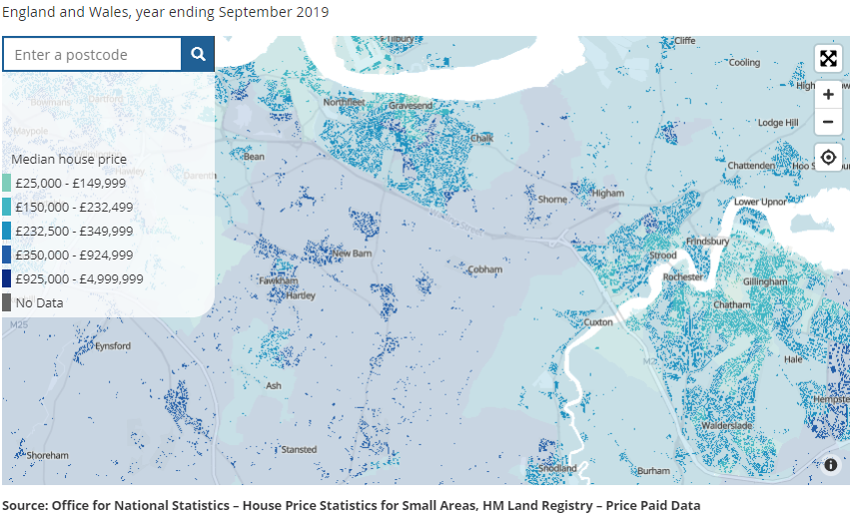
A range of organisations are involved in the early stages of the development process including landowners, investors, occupiers, developers, lenders, architects, engineers, surveyors, planners and real estate agents. The process does not take place in a vacuum; it is affected by and contributes to changes in social trends, economic conditions and the regulatory environment
Developing houses is often a complex process. There are a number of challenges and barriers to overcome before a buyer can take ownership of a property. Many of these barriers are economic in nature, for example access to finance for both developers and potential house buyers, whilst others may be more site-specific such as land contamination. These barriers affect both the supply and demand side of housing delivery. The following provides a brief summary of the key challenges associated with bringing housing development forward in general. It should be noted that the barriers will range from site to site and are dependent, to an extent on the size or nature of a developer.

Resources
- Skills and labour availability
- Shortage and cost of materials
- Availability of sites
- Availability of developers and registered providers to deliver housing

Financial
- Land value expectations
- Access to finance for developers/registered providers
- Access to finance for potential home owners
- Cash flow and interest payments
- Grant / loan funding from Homes England
- Strength of market – investor confidence
- The price the land was bought for compared with its value today

Site Specific Constraints
- Land contamination
- Complexity of land ownerships and ‘ransom’ situations
- Access arrangements
- Landscape
- Flood risk, drainage and utilities
- Archaeology
- Wildlife and nature
- Heritage assets (e.g. listed buildings)
- Local opposition
- Legal (e.g. covenants)
- Infrastructure capacity (Highways, Water, Waste, Electricity, etc)

Infrastructure Contributions

- Affordable housing
- Health contributions
- Open space
- Drainage schemes
- Housing mix
- Education contributions
- Highway improvements
Other infrastructure requirements

Any number of these issues can negatively influence the financial viability of a development. In some cases causing long delays, because local effective demand is not able to overcome these supply-side constraints. Put simply the amount local people are prepared to pay does not give the return needed by the developer, to develop the site. To overcome this, the Council will work proactively with local stakeholders via the ‘Development Sites Implementation Group’ to address where practicable, the impediments to delivery.
Whilst many of these issues are primarily the responsibility of the promoter / developer, a number of the actions highlighted in this action plan will assist:
- Greater scrutiny of sites at plan making stage including clarity about lead in periods for sites with constraints
- Allocation of additional sites, not just minimum requirement
- Re-freshed pre-application advice service
- Development Sites Implementation Group
- Strict application of the validation list requirements will assist in identifying problems and their solutions in the pre-submission stage

6. Demand side issues
Population and household projections, coupled with evidence gathered through the Strategic Housing Market Assessments and the Rural Housing Needs Assessments, all identify that there is significant need for new homes in the Borough. Such data when reviewed against the Council’s waiting list and national statistics also shows that there is an affordability issue. Wages have not kept up with house price growth and over time more and more people have either been priced out of the housing market or they have had to utilise a greater portion of their income on housing costs. Local affordability is illustrated in Figure 12 , slow rates of building on some sites (e.g. land at Coldharbour Road) and a clear lack of progress on others (e.g. Northfleet Embankment West) means reduced housing delivery in the Borough and inevitably higher property prices. The affordability ratio set out in Figure 12, also plays a key role in determining the number of homes that have to be delivered within Gravesham via the Standard Method (please see the Borough’s five year housing land supply statement for further information).
Through the plan making process the Council will seek to ensure that policies are put in place that guide developers to deliver the right size and type of homes in the Borough, and the homes that meet local needs.
The ongoing pandemic has had and will continue to have impacts upon housing demand and levels of construction. The first Covid-19 lockdown commenced on 23rd March 2020, as such the impact on housing completions for the financial year 2019/20 would have been limited. During the 20201/22 the pandemic has had a greater impact on the economy and the construction centre. Whilst Government measures such as the Stamp Duty holiday will have helped the housing market, housing market commentators are advising that greater economic uncertainty and greater levels of unemployment will result in falling property prices, falling rental values and falls in construction. The pandemic is also influencing where households want to live and the types of properties households wish to purchase, with a greater number of households looking to purchase low density developments in suburban and rural areas e.g. homes with gardens, rather than apartments outside of Central London.

Figure 12: Ratio of median house price to median gross annual workplace based earning Gravesham only, 1997-2019

7. Infrastructure and Public Services Provision
The Local Plan Core Strategy (2014) was produced and supported by an Infrastructure Delivery Schedule (IDP). The IDP has been developed with input from utility providers and service providers and identifies the improvement to existing or new infrastructure required to support the planned growth of the Local Plan. Since its creation the Ebbsfleet Development Corporation has also taken on a lead roll in ensuring suitable infrastructure is put into place within the Garden City. A revised IDP is being produced as part of the emerging Local Plan.
The Council has considered whether the current provision of infrastructure in the Borough is acting as a barrier for the delivery of new homes. For the current planning permissions in place, there are no infrastructure barriers preventing the commencement of sites.
There are examples in the Borough of infrastructure that was to be delivered as part of a development site but subsequently found to be undeliverable due to viability issues. Largest of these was the bridge linking Springhead Quarter to Ebbsfleet Station. The developer had agreed a significant package of transport infrastructure when the initial outline permission was given for the development at Ebbsfleet. More detailed viability work on a phase by phase basis identified that some of the infrastructure such as the bridge could not be paid for by the development .The Ebbsfleet Development Corporation have addressed this by forward funding infrastructure and that has enabled infrastructure such as the Springhead Link Bridge to be opened in July 2020.
The investment being made in the Garden City however cannot be easily replicated elsewhere, primarily because the Government directly funds the Ebbsfleet Development Corporation to bring forward development in the Garden City. Similar funding is not made available to the Council to bring forward infrastructure and address service shortfalls in other parts of the Borough. Concerns regarding the capacity of infrastructure such as the highway network, water and waste resources and the capacity of services such as health care are at the forefront of local residents concerns.
Recent growth has not been complemented by suitable investments in local infrastructure and services, as funding opportunities became and remain limited. The inability of developers to adequately fund local infrastructure and public services harms local perception of new development. There is a recognition that further investments need to be made into local infrastructure, and the Council will continue to work with partners to identify and bid for funding that enhances local provision in terms of both infrastructure and services.

Conclusion
The only way to meet the test is enhanced delivery and as highlighted above the Council continues to undertake a range of actions related to its various roles. These actions are summarised in the form of a work programme at Appendix A.
At the same time, the text is inherently backward looking with paragraph 215 of the NPPF defining the thresholds substantially below the housing requirement as:
- November 2018 indicate that delivery was below 25% of housing required over the previous three years;
  - Considering 3 year period from 1/4/2015-31/3/2018
- November 2019 indicate that delivery was below 45% of housing required over the previous three years;
  - Considering 3 year period from 1/4/2016-31/3/2019
- November 2020 and in subsequent years indicate that delivery was below 75% of housing required over the previous three years.
  - Considering 3 year period from 1/4/2017-31/3/2020

Appendix A: Work Programme
This is a living document will evolve and be refined over time.
1. GRAVESHAM BOROUGH COUNCIL AS A LOCAL PLANNING AUTHORITY
Lead | Action / Aim | Timeframe | Performance Measure
Planning Policy | Progressing work on the LPCS Partial Review and Site Allocations and Development Management Policies Document | Regulation 18 Stage 2 Consultation: Undertaken Oct-Dec 2020,  Regulation 19 Consultation: 2nd half 2021,  Submission and adoption: Dec 2022. | Adoption of Local Plan Partial Review and Site Allocations and Development Management Policies document in line with Local Development Scheme
 | There is a requirement from Government for Local Planning Authorities to make progress with their emerging Local Plans during the pandemic. This is emphasised by correspondence received from the Chief Planner at MHCLG in 2020, and a more recent Ministerial Statement from the Minister of State, The Rt Hon Christopher Pincher MP
Development Management | Developing a local validation list | A local validation list has been adopted and has applied to planning applications since 1st April 2020, see https://www.gravesham.gov.uk/home/planning-and-building/apply-for-planning-permission/local-list-of-validation-requirements | Sustained reduction in applications backlog  PS1 and PS2 returns performance  Increased public use of Council’s website in terms of web metrics and a corresponding decrease in public telephone inquiries, in areas where information available on line.
 | Developing an accredited agent scheme | During 2021/2022
 | Continually review the appropriateness of planning conditions | Ongoing
 | Increase the transparency of the planning obligations process | An Infrastructure Funding Statement has been published, see https://www.gravesham.gov.uk/home/planning-and-building/local-plan/community-infrastructure-levy-and-planning-obligations . In due course a Planning Obligations SPD will be progressed (by 2023)
 | Reduce backlog of planning applications and keep to a minimum thereafter | Ongoing
 | Review and improve information disseminated through the Council’s website | Ongoing
 | Address data quality | Ongoing
 | More effective use of IT | Ongoing
 | Maintaining a fully resourced and skilled workforce | Ongoing
Development Sites Implementation Group | 1. Identify barriers to delivery.  2 to work with developers, landowners and other departments within the Council to ensure that the Council has done everything reasonable it can do to overcome these barriers.  3. to identify areas that other bodies will need to investigate to overcome remaining barriers.. | Ongoing | Implementation, progression and development on major sites
2. GRAVESHAM BOROUGH COUNCIL AS A LANDOWNER & LANDLORD
Housing Strategy and Development | Bring forward affordable housing at a number of sites i.e. Albert Murray Close, Arnold Avenue, Barr Road, Constable Road / Rembrandt Drive, Mark Square Garages St Hilda’s, St Patricks Gardens, Valley, Drive, Whitehill Road, Wilberforce Way. | Ongoing | Residential completions 2020-2025
Housing / Housing Strategy and Development | Review housing stock to identify opportunities for intensification. | Ongoing | Identification of additional development / redevelopment opportunities
Corporate Services | Consider the merits of creating an a Local Authority Trading Company (LATCO) to increase housebuilding rates | The Council has formed a new Local Authority Trading Company (LATCo) known as Rosherville Ltd. One of the key targets of this company is to deliver housebuilding and regeneration within the Borough, its initial projects will be The Charter and St Georges Phase 2. | Completed
3. GRAVESHAM BOROUGH COUNCIL WIDER ROLE
Planning Policy / Development Management | 1. Improve the public’s understanding of the planning system, the role of the NPPF, and the part the Council has in shaping development.  2 increase the public’s participation in the plan making process, subsequently fostering a greater sense of ownership | Ongoing  A number of measures have been taken to improve guidance to members of the public, including the adoption of the following Supplementary Planning Documents:  - Conservation Area Maintenance/Replacement Windows and Doors Guidance SPD  - Householder Extensions/Alterations Design Guidance Supplementary Planning Document SPD | Reduced complaints, more useful interactions with the public, improved planning applications.
Communities / Planning Policy / Communications | Through more effective placemaking and marketing of the Borough, to promote a clearer vision for the Borough and key development locations | Ongoing  Work is being progressed on Supplementary Planning Documents and the emerging Local Plan | Land value uplift  Reduced Town Centre vacancy rates  % of planning permissions implemented  Improvements to headline estimates of personal well-being from the Annual Population Survey  Improved average earnings
Housing and Regeneration | Identify opportunities for greater involvement in site assembly and delivery | Ongoing  Officers have been given authority to Compulsory Purchase land to assist with delivery of sites such as the former Gravesend Police Station and Canal Basin. | Reduction in stalled sites and development of Opportunity Areas and Key Sites allocated in Local Plan Core Strategy
4. GRAVESHAM BOROUGH COUNCIL AS A PARTNER
Housing and Regeneration / Corporate Services | Identify and bid for funding to deliver the development and infrastructure, needed in the Borough | Ongoing | External funding received directly / indirectly e.g. delivery of infrastructure by partners
5. SUPPLY SIDE
Development Sites Implementation Group | Work with stakeholders and developers, looking to identify and overcome, where practicable, impediments to delivery. Reducing the time between permission and build. | Ongoing | Increased development delivery rates, and progress on stalled sites.
Development Management / Planning Policy | Ensure schemes are deliverable and developable during both plan making and decision making stages;  Allocate sufficient sites to provide greater choice for developers;  Enhanced pre-application service;  Implementation of validation list | Ongoing | Increased development delivery rates
6. DEMAND SIDE
Economic Development | 1. Work to stimulate the local economy and to improve incomes in the borough, directly through a review of GBC’s economic development offering and through our SELEP and KMEP membership and activity.  2. Based on concerns raised by residents and members, the Council is also working with partners, identifying opportunities for improving infrastructure and service provision. This includes exploring other avenues of funding. | Ongoing | Improved Gross Value Added and Average Income Levels compared to present.  Housing affordability being more comparable to nearest neighbours and improving
7. Infrastructure and Public Services Provision
Housing and Regeneration / Communities | Work with partners to identify and bid for funding that enhances local provision in terms of both infrastructure and services | Ongoing | Success rate in obtaining grant funding

