Medway Council’s Cumulative Impact and Stress Area Policies

Introduction

For a Local Authority to have a policy around Cumulative Impact, a Cumulative Impact Assessment must be carried out.

The current policy was approved by Full Council on 22 April 2021 and put into effect from 1 May 2021. Unless brought for review at an earlier time, a Cumulative Impact Assessment is valid for a period of 3 years, therefore this policy will expire on 31 April 2024.

The Council and the police have adopted several special measures to address issues of crime and disorder and anti-social behaviour. These measures have been considered when determining the CIP and SAP areas. Measures have included:

- Additional police staffing, particularly at weekends.
- Use of CCTV along with camera operatives.
- Adoption of Alcohol Control Zones, to be superseded by Public Place Protection Orders.
- Encouraging businesses to belong to the Medway Safer Business Partnership, which includes a radio communication system.
- Using enforcement powers available to the police, licensing officers and trading standards officers under the Licensing Act 2003.

New Cumulative Impact Policy areas of Medway may be considered.

Cumulative Impact

In accordance with the Section 182 Statutory Guidance the cumulative impact of licensed premises on the promotion of the licensing objectives is a proper matter for the Authority to consider.

‘Cumulative impact’ is defined in the Statutory Guidance as the potential impact on the promotion of the licensing objectives of a significant number of licensed premises concentrated in one area. Cumulative Impact Policies (CIPs) may relate to premises licensed to carry out any licensed activity, including the sale of alcohol for consumption on or off the premises and the provision of late-night refreshment.

The Statutory Guidance sets out the steps to be followed when considering whether to adopt a special policy within the Policy these include:

- Identify concern about crime and disorder; public safety; public nuisance; or protection of children from harm.
- Consider whether there is good evidence that crime and disorder or nuisance are occurring, or whether there are activities which pose a threat to public safety or the protection of children from harm.
- If such problems are occurring, identify whether these problems are being caused by the customers of licensed premises, or that the risk of cumulative impact is imminent.
- Identify the boundaries of the area where problems are occurring.
- Consult with those specified by section 5(3) of the Licensing Act and subject to the outcome of that consultation, include and publish details of any special policy in the licensing policy statement.

Cumulative Impact Policy

This policy applies to applications for new premises licences, substantial variations, and provisional statements, for the sale of alcohol for consumption off the premises.

It is the Authority’s policy to refuse premises licence applications for the sale of alcohol for consumption off the premises which fall within the Cumulative Impact Policy areas, dependent on the specific policies in these areas.

Reason for the policy
Having regard to the Guidance, Medway Council, as the Authority, has consulted on the issue of cumulative impact and, considering the evidence presented to it and the views of the respondents to the consultation, has adopted a CIP in several areas in Medway.

These areas have been identified as areas of concern because of the cumulative effect of the concentration of licensed premises and their customers, which has led to serious problems of crime, disorder and public nuisance affecting residents, visitors, and other businesses. In addition, public services, including police, health and emergency authorities and environmental services (cleansing and refuse services) are also being placed under strain.

This policy gives further information and details of each CIP area. The evidence presented to the Authority is distinct for each CIP area and therefore each area is addressed on an individual basis. These policies represent the Authority’s view of the best way of addressing the licensing objectives in those areas of Medway which are subject of a cumulative impact policy.

Expectations of the Authority
An application which falls within the CIP will be expected to explain how it will promote the four licensing objectives so the premises will not adversely affect the evidenced alcohol related problems and issues in the CIP area.

While it is a matter for the applicant what details are included in the operating schedule, where it departs from the relevant cumulative impact policy the licensing sub-committee will expect there to be a good reason for the departure if it is being asked to make an exception to this policy.

What the Authority will do
Where the Authority’s discretion has been engaged it will always consider every application on its merits, whether it has complied with the relevant policy or not and will only amend or add to an operating schedule to the extent that is appropriate to promote the licensing objectives.

When the CIP is applied, and there are relevant representations, there is a rebuttable presumption of refusal by the Authority in all but exceptional circumstances, unless the applicant can demonstrate the premises will not adversely affect the licensing objectives.

It is not possible to give a full list of examples of when the Council may treat an application as an exception. However, in considering whether a particular case is exceptional, the Authority will consider the reasons underlying the CIP for that area. Examples of factors the Authority will not consider as exceptional include:

- The premises will be well managed and run, as all licensed premises should meet this standard.
- The premises will be constructed to a high standard.
- The applicant operates similar premises elsewhere, such as in another licensing authority area, without complaint.

The Authority’s policies, in relation to the cumulative impact, are concerned with the cumulative effects of licences on the area. Therefore, a case is most unlikely to be considered exceptional unless it is directed at the underlying reason for having the policy. Exceptions to the CIP must be for genuinely exceptional reasons.

The Authority recognises that there are licensed premises which are unlikely to add significantly to the saturation in the defined areas and will consider each application on its merits.

The presence of the CIP does not relieve responsible authorities or any other person of the need to make a relevant representation. Where no relevant representations are received, there is a presumption that any application received will be granted in terms that are consistent with the submitted operating schedule. This presumption remains, even in a CIP area.

Cumulative Impact Areas

Having considered the Statutory Guidance and representations from the Community Safety Partnership, which included evidence from the Community Safety Unit, Kent Police, Public Health, residents and businesses, the Council have identified four areas as being suitable for a Cumulative Impact Policy (CIP):

- Chatham High Street and Railway Street area
- Gillingham High Street, Canterbury Street and Gillingham Road area
- Luton Road area
- Rochester High Street area

The evidence considered by the Licensing and Safety Committee was initially submitted on 8 March 2017 in the Cumulative Impact Assessment. Given that the Cumulative Impact Assessment (CIA) must be reviewed every three years a new CIA was undertaken using current statistics, statements and other evidence, and presented to full council on the 22 April 2021. This assessment can be found as an appendix to the report submitted to the Licensing and Safety Committee.

The policy context aims, and types of licensed premises covered by each CIP is different in each area based on the evidence presented to the Authority, the opinions of ward councillors and the responses and views of local residents and businesses following the consultation process.

The Authority recognises that there are licensed premises which are unlikely to add significantly to the problems in the defined areas and will consider each application on its merits.

The presence of a CIP does not relieve responsible authorities or any other person of the need to make a relevant representation. Where no relevant representations are received, there is a presumption that any application received will be granted in terms that are consistent with the submitted operating schedule. This presumption remains, even in these areas.

Stress Area Policy (SAP)

This policy applies to applications for new premises licences, substantial variations and provisional statements for the sale of alcohol for consumption off the premises.

It is the Authority’s policy to expect premises licence applications for the sale of alcohol for consumption off the premises in Stress Areas to demonstrate they will promote the licensing objectives so as not to add to the alcohol harms in these areas, dependent on the specific policies in these areas.

When its discretion is engaged it is the policy of the Authority that applications for the sale of alcohol for consumption off the premises which fail to demonstrate this are likely to be refused, or have conditions placed on the licence consistent with the promotion of the licensing objectives.

Reason for the policy
Having regard to the Guidance, the Authority has consulted on the issue of cumulative impact and, considering the evidence presented to it and the views of the respondents to the consultation, certain areas have been identified as being of concern, although the evidence does not support a CIP. These areas are termed as stress areas. These areas are listed, and the relevant policy is outlined at in this policy

These areas have been identified as areas of concern because of the effect of the concentration of licensed premises and their customers, and which have highlighted problems of crime, disorder and public nuisance affecting residents, visitors, and other businesses. In addition, public services, including police, health and emergency authorities and environmental services (cleansing and refuse services) are also being placed under strain.

This policy describes the general aims of the Stress Area Policy and the detailed aims for each SAP area as the evidence is distinct for each.

This policy represents the Authority’s view of the best way of addressing the licensing objectives in those areas of Medway which are subject of a stress area policy.

Expectations of the Authority
The Authority expects applicants to address in detail all the issues outlined in the relevant policy, offering measures to fully promote the licensing objectives.

While it is a matter for the applicant what details are included in the operating schedule, where it departs from the relevant stress area policy the licensing sub-committee will normally expect there to be a good reason for the departure if it is being asked to make an exception. However, the Authority will not apply this policy rigidly, and will always take into account the merits of any application and promote the licensing objectives.

What the Authority will do
Where the Authority’s discretion has been engaged it will always consider every application on its merits, whether it has complied with this policy or not, and only amend or add to an operating schedule to the extent that is appropriate to promote the licensing objectives.

The Authority’s policies, in relation to stress areas, are concerned with the cumulative effects of licences on the area. Therefore, a case is most unlikely to be considered an exception unless it is directed at the underlying reason for having the policy.

Applications for new licences to replace licences which have lapsed because of the failure to submit an interim authority notice in due time in the event of the death or insolvency of a licence holder will be considered by the licensing authority as possible exceptions. Unless there are representations which indicate there have been problems associated with the premises, licences may be granted with conditions which replicate the effect of those of the previous licence.

The Authority recognises that there are licensed premises which are unlikely to add significantly to the saturation in the defined areas and will consider each application on its merits.

The presence of the SAP does not relieve responsible authorities or any other person of the need to make a relevant representation. Where no relevant representations are received, there is a presumption that any application received will be granted in terms that are consistent with the submitted operating schedule. This presumption remains, even in a SAP area.

Stress Areas

The proposed CIP areas define the centre, as far as is possible, of identified alcohol related harms. These harms, as well as the related licensed premises, extend beyond the boundaries of these zones. As with any policy that delineates a specific area, its effectiveness may be undermined if alcohol is readily available from nearby licensed premises. In addition, displacement from the proposed CIP areas could also have a detrimental effect on nearby areas where there is already concern, although not to such a level where a CIP can be justified.

In view of the above, the Authority has decided to designate certain areas as ‘stress areas’, where there is concern about alcohol related crime associated with a density of licenced premises, although not to a level where a CIP can be justified and where there are concerns regarding displacement of alcohol related harm into, and from, a CIP area. A Stress Area Policy (SAP) will be adopted for these areas.

Three areas have been identified as stress areas:

- South Gillingham
- The High Street and A2 between Chatham and Rochester
- Strood town centre

In the defined area the Authority will expect applicants to pay special attention to the measures they offer in their operating schedule so they promote the four licensing objectives and show they will not add to the accumulation of problems in the area. When the Authority’s discretion is engaged and applications fail to address all the appropriate measures, they may be refused or have conditions applied to promote the licensing objectives.

The proposed measures in each policy are considered appropriate, depending on the type of operation, to promote the licensing objectives in these areas, taking into account the evidence of alcohol related crime, disorder and public nuisance in these areas Applicants are not limited to these measures and should propose any measures in accordance with the risk assessment recommended as part of the application process in the S182 Statutory Guidance.

Where the Authority’s discretion has been engaged, applicants should be prepared to explain why any recommended measures have not been included in an operating schedule

The Authority recognises that there are licensed premises which are unlikely to add significantly to the problems in the defined areas and will consider each application on its merits.

The presence of the ‘stress area’ policy does not relieve responsible authorities or any other person of the need to make a relevant representation. Where no relevant representations are received, there is a presumption that any application received will be granted in terms that are consistent with the submitted operating schedule. This presumption remains, even in these areas.

Policy context and aims

Medway, and its centres, such as Rochester, Chatham, Gillingham, and Luton, play an essential role in community life and are intrinsic to perceptions of place. Centres bring people together to shop, do business, and enjoy leisure time, and can also be a place to live. Changes in how people shop have brought about changes on our high streets, with the closure of many retailers. Alterations to permitted development rights have extended the ability to change the use of buildings, such as shops, to restaurants and homes.

The Authority recognises that the quality of the local environment has an important influence on both the safety of an area and the perception of its safety by residents. Our residents have told Medway Council they are concerned about safety and the way crime and anti-social behaviour are dealt with, particularly in some of the more deprived areas, such as Luton, Chatham and Gillingham. The Authority encourages any application which seeks to improve and enhance our centres highlighted within the CIP or SAP process, but which will not add to the cumulative impact of the alcohol related harms experienced by residents.

Medway has a strong cultural, sporting and heritage offer. Many local people work in the leisure and tourism industries, and they contribute to the region of £265 million to the local economy. Together they contribute to the wellbeing of residents by raising levels of civic pride, improving physical and mental health, and delivering local jobs. Furthermore, Medway’s identity to the world is, to a great extent, shaped by the nature of its appeal to visitors.

There is potential to increase visitor numbers and local engagement and raise Medway’s image as a tourist destination by strengthening this offer. Successful centres provide a range of accessible services and facilities and contribute to the image of Medway as the places (i.e., the successful centres) which many visitors first see when they arrive in the area. The Authority encourages applications which seek to improve Medway’s tourist facilities within the confines of the CIP or SAP areas, but which will not add to the cumulative impact of alcohol related harms.

The single largest type of premises in Medway is off licenced premises, which has also seen the highest increase over the last 5 years. Most of these are small convenience/newsagents/corner shops, many of which sell cheap, strong alcohol, commonly termed ‘super strength’ beer, cider, and lager.

Over recent years the Authority has become increasingly aware of the problems experienced in our local communities arising from the availability of alcohol for sale at local shops for consumption off the premises. The public face of these problems shows in congregations of street drinkers or alcohol dependent persons drinking on the streets and public places causing nuisance, anti-social and intimidating behaviour at all times of the day and night. The hidden harms of the ready availability of cheap alcohol manifests itself in unacceptable rates of domestic abuse and alcohol health harms, such as alcohol related hospital admissions and ambulance callouts where alcohol has been deemed to be a contributory factor, particularly in the more deprived areas, and where there are concentrations of these type of premises.

The Authority aims to work with the off licensed trade to raise standards, ensuring all appropriate procedures are in place, promoting the licensing objectives and addressing the above concerns as far as possible within the ambit of the licensing process. However, it has been recognised that in those areas of Medway identified in the CIP and SAP process, poorly run off-sales establishments can provide vulnerable people with access to cheap, strong drinks without any supervision of how, where and by whom the alcohol is consumed, leading to crime, disorder and public nuisance that is affecting the quality of life of our residents, businesses, and visitors.

It has been recognised as part of the CIP process that there are alcohol related harms associated with the density of licensed premises in the areas identified above. However, the intention is not to simply stop the development of licensed premises in these areas. The CIP and SAP are intended to complement an overall approach which will be area specific and intended to promote those types of licensed premises which are considered by the Council as consistent with supporting the wider strategies, plans and policies in place to improve Medway.

Therefore, the overall aim of both the CIP and SAP is to encourage a diversity of licensed premises which complement, enhance and support the communities in which they are situated and support the overall strategic goals of Medway Council.

In support of the wider goals, strategies and policies of Medway Council, the Authority wants to encourage, depending on the specific area:

- Premises which extend the diversity of entertainment and attract a wider range of participants.
- Family friendly venues, where adults and children can go. These may be specific places where children attend, but can also be premises appealing to adults, but which also have a provision for children.
- Exhibition and art venues.
- Theatres and cinemas.
- Restaurants and cafés where the sale of alcohol is ancillary to the sale of food.
- Community venues.
- Good quality hotels and other premises which support the tourism industry and complement Medway’s heritage.

Where the Authority’s discretion is engaged, the following types of premises, highlighted in red below, will fall within the ambit of the appropriate policy.

 | Chatham High Street | Gillingham High Street | Luton Road | Rochester High Street | Stress areas
Pubs/bars/clubs | No | No | No | No | No
Off licence | Yes | Yes | Yes | Yes | Yes
Restaurant/café | No | No | No | No | No
Ancillary alcohol sales | No | No | No | No | No
Takeaways | No | No | No | No | No
Members’ clubs | No | No | No | No | No

All policies will apply to the following types of licensing application:

- New premises licence applications
- Material variations for existing premises licences
- Provisional statements for premises licences

To assist applicants the definition for each type of premises listed above is contained at the end of this policy. The examples given are not definitive and, if the Authority’s discretion is engaged it will be for members to decide if a specific premises falls within the relevant policy on the evidence provided.

Definition of types of licensed premises
Type of licensed premises | Description of premises
Pubs/bars/clubs | Premises which primarily supply alcohol for consumption on the premises, with or without the provision of off sales and with or without the provision of entertainment, hot food and hot drink for consumption on or off the premises.
Off licences | Premises that supply alcohol primarily for consumption off the premises, including convenience stores, supermarkets and newsagents.
Restaurants | Premises which primarily supply substantial table meals for consumption on the premises and dining is the main activity for customers.  Fast food premises and takeaways are not considered as ‘restaurants’ for the purposes of this policy.
Ancillary alcohol sales | For the purposes of this policy venues where alcohol is ancillary to the main purpose of the premises, and alcohol sales make up a small percentage of the business. This type of premises may include:  Cinemas  Theatres  Bowling alleys  Hotels and B&B premises where alcohol is provided for consumption on the premises for the benefit of residents  Art galleries/exhibition venues  Hairdressers/florists  ‘Ancillary alcohol sales’ will NOT apply to  Sexual entertainment venues  Hotel bars with public access (not just available to customers staying in overnight accommodation)
Takeaways | Premises that provide late-night refreshment either by way of takeaway for immediate consumption, or fast food on a counter or self seated basis.
Members’ clubs | A members’ club is one that complies with Sections 62 and 64 of the Licensing Act 2003, such as Working Men’s Clubs, and is run under a club premises certificate, not a premises licence.

Cumulative Impact Policy 1 - Chatham High Street

Evidence summary
- This central part of Medway is ranked in the most deprived 20% of super output areas nationally, with crime being a main area of concern.

- Evidence shows this area has unacceptably high rates of:

  - Alcohol related crime and disorder, with Chatham High Street and surrounding areas showing as a hot spot for the following:
    - anti-social behaviour
    - assaults
    - criminal damage
    - public order
    - sexual offences
    - arrests for:
    - public order
    - drunk and disorder
    - assaults on police
  - Alcohol related hospital admissions:
    - both River and Chatham Central wards have some of the highest rates of alcohol related hospital admissions.
  - Alcohol related ambulance callouts:
    - the lower part of River ward, covering Chatham High Street, has the highest number of ambulance callouts where alcohol has been deemed to be a contributory factor.
  - Medway Hospital A&E assault data:
    - Chatham High Street is the area in Medway with the highest number of reported assaults.
  - Chatham High St and surrounding areas have particular problems with street drinking and associated nuisance, such as begging, intimidating behaviour, litter and public urination and defecating.

- The Community Safety Unit identified issues around the availability and consumption of high-strength cheap beer and cider linked to health issues, public nuisance, anti-social behaviour and crime.

- All respondents to a community questionnaire felt licensed premises in this area contribute towards alcohol related issues, and that customers from licensed premises contribute to problems of public nuisance and public safety. The majority identified off licences as the main concern, followed by pubs and bars. All respondents felt the number of licensed premises in the area contribute to alcohol related problems.

- The evidence highlighting the harms was first considered by the Licensing and Safety Committee on the 8th March 2017. This evidence has been superseded following a review of the Cumulative Impact Assessment (CIA) This fresh evidence supporting the continuation of the policy can be found at Link to current CIA from police and Public Health

- Cumulative Impact Policy 1 will apply to the following applications for the sale of alcohol for consumption off the premises.

  - New premises licence applications
  - Material variations for existing premises licences
  - Provisional statements for premises licences

Chatham High Street overview and policy aims

- The High St and surrounding area has a mix of cafés, restaurants, pubs and a few late-night venues, as well as many fast food type outlets. The traditional, small community pub has seen a real decline in recent years, mainly leaving larger town centre premises, which benefit from a licence allowing later operation hours. Kent Police and Chatham residents have evidenced alcohol related crime, disorder and nuisance associated with both day time alcohol misuse and the night-time economy.

- There has been a growth of off licensed premises in the CIP, and surrounding, area, most of which are small convenience stores, corner shops and newsagents. Many of these sell products which are known as ‘super strength’ beer and cider i.e. cheap beer and cider products over 5.5%ABV, making cheap, high-strength alcohol readily available. Responsible authorities, other agencies, residents and businesses in Chatham have provided evidence showing the number of off licensed premises has led, in part, to issues of street drinking and associated crime, disorder and nuisance as well as other, more hidden alcohol related harms, such as domestic abuse and health harms. Where its discretion is engaged the Authority regards the prevention of public nuisance, crime and disorder to residents as a material consideration in any application.

- Chatham has undergone extensive regeneration in recent years, which will continue along the riverside and in the town centre, increasing the number of residents. A recently commissioned study recommended the Council should plan for a stronger evening economy in Chatham through commercial leisure provision, particularly restaurants and cafés.

- Chatham is the location of extensive heritage assets, such as the Historic Dockyard and Fort Amherst. The Authority want to support and encourage businesses which complement and support these assets, encouraging tourists and increasing dwell time, growing local spend and improving the economic health of Chatham town centre.

- The development of a cultural infrastructure is also a key goal. Establishing a creative quarter around Sun Pier House, with exhibition opportunities, as well as quality hotels in Chatham for visitors, is important to develop the area as a tourist destination.

- Notwithstanding the existence of the CIP, members are supportive of applications which will positively benefit the town centre in line with the aspirations outlined above. The kind of application which would be encouraged is for family friendly venues, such as restaurants, community venues and other leisure businesses where the sale of alcohol is ancillary to the main activity.

- The key aim in Chatham town centre is to encourage and expand the leisure, tourism and business visitor offer, with the intention of providing premises attractive to all age groups, and a diversity of licensed premises in both the day and night-time economy including:

  - Restaurants and cafés, with an emphasis on good quality family friendly venues.
  - Premises where the sale of alcohol is ancillary to the main business, such as:
    - Exhibition and art venues
    - Theatres and cinemas
    - Hotels
    - Venues which complement and enhance Medway’s heritage

- This is a less restrictive approach than is suggested in the Statutory Guidance, which suggests that Licensing Authorities can adopt a policy of refusing all new licences in areas where special policies on cumulative impact apply, subject to their discretion being engaged.

Chatham High Street CIP area map

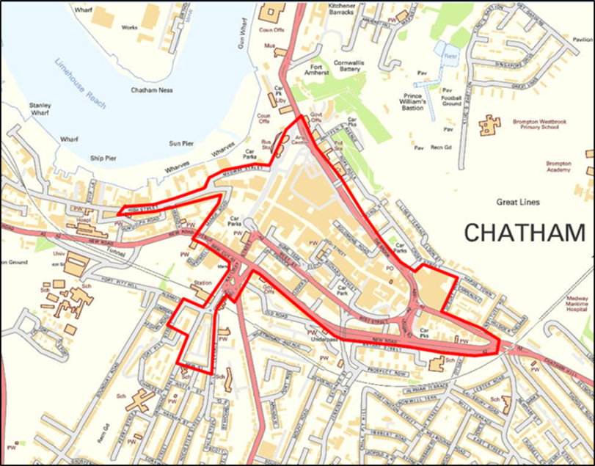

- Addresses on both sides of all roads shown in the above map are included in the CIP unless otherwise stated.

- While every effort has been made to include all roads within the above CIP area, there may be omissions, errors or additions due to ongoing development, and the following list is only intended as a guide. The area delineated above is the area covered by the CIP and it is the applicant’s responsibility to confirm the location of their premises.

List of roads included in the Chatham High Street CIP

A2 New Road from its junction with Chatham Hill to its junction with Manor Road
A230 Maidstone Road to the Bus Station junction
A231 The Brook
A231 Dock Road to its junction with Globe Lane (bus station)
Batchelor Street
Best Street
Clover Street
Cross Street
Gibraltar Hill
Globe Lane
High Street between the junction with Chatham Hill and the second junction with Gundulph Road (travelling from Chatham town centre)
James Street
Manor Road
Medway Street
Meeting House Lane
Military Lane
New Street
Ordnance St from its junction with New St to Ordnance Terrace
Ordnance Terrace from its junction with Ordnance Street to Railway Street
Railway Street
Rhode Street
Richard Street
Rochester Road to its junction with New Street
Rome Terrace
Slicketts Hill
Solomons Road
The Paddock
Union Street
Upbury Way
Waterfront Way
Whittaker Street

Cumulative Impact Policy 2 - Gillingham High Street

Evidence summary

- Gillingham High Street and the surrounding area suffers from widespread multiple deprivation.

- Evidence shows this area has unacceptably high rates of:

  - Alcohol related crime and disorder, with Gillingham High St and surrounding areas showing as a hot spot for the following:
    - anti-social behaviour
    - domestic abuse
    - criminal damage
    - assault
    - public order
    - arrests for:
      - drunk and disorderly
      - public order offences
  - Alcohol related hospital admissions:
    - both Gillingham North and South wards have some of the highest rates of alcohol related hospital admissions.
  - Alcohol related ambulance callouts:
    - both Gillingham wards are in the top 4 wards in Medway from 2011 onwards for ambulance callouts where alcohol has been deemed to be a contributory factor.
  - Medway Hospital A&E assault data:
    - Gillingham High Street is a hot spot location for assaults reported at Medway A&E.
  - Gillingham High St and surrounding areas have particular problems with street drinking and associated nuisance, such as begging, intimidating behaviour, and litter.

- The Community Safety Unit identified issues around the availability and consumption of high-strength cheap beer and cider linked to health issues, public nuisance, anti-social behaviour and crime.

- All respondents to a community questionnaire felt licensed premises in this area contribute towards alcohol related issues, and that customers from licensed premises contribute to problems of disorder and public nuisance. Nightclubs, pubs and off licensed premises were identified as contributing to alcohol related problems.

- The evidence highlighting the harms was first considered by the Licensing and Safety Committee on the 8th March 2017. This evidence has been superseded following a review of the Cumulative Impact Assessment (CIA) This fresh evidence supporting the continuation of the policy can be found at Link to current CIA from police and Public Health

- Cumulative Impact Policy 2 will apply to the following applications for the sale of alcohol for consumption off the premises.
  - New premises licence applications
  - Material variations for existing premises licences
  - Provisional statements for premises licences

Gillingham High Street area overview and policy aims

- Gillingham is the second largest centre in Medway after Chatham. It primarily serves the local community, which makes up a substantial part of Medway. It has good sports and leisure facilities, with Gillingham Football Club to the east of the CIP area, and a large leisure and sports facility to the west. There is also access to large areas of green space, particularly the Great Lines Heritage Park.

- Residents live in many of the roads and streets within the CIP area, which also link the High Street to the nearby residential areas, both north and south of the High Street. The area surrounding the High Street is one of the most densely residential areas in Medway. Kent Police and Gillingham residents have evidenced alcohol related crime, disorder and nuisance associated with both day time alcohol misuse and the night-time economy. Where its discretion is engaged the Authority regards the prevention of public nuisance, crime and disorder affecting residents as a material consideration in any application.

- The Universities at Medway complex is within walking distance and there is a large student population, some of whom live in student accommodation in and around the High Street, within the CIP area.

- While there are cafés and restaurants, these tend towards being value for money and fast food type outlets. There are pubs and a few late-night venues in the area but the traditional, small community pub has seen a real decline in recent years. Kent Police and Gillingham residents have evidenced alcohol related crime, disorder and nuisance associated with the night-time economy.

- There has been a growth of off licensed premises in the CIP and surrounding area, most of which are small convenience stores, corner shops and newsagents. The High St and surrounding area has the highest concentration of off licenced premises in Medway. Many of these sell products which are termed as ‘super strength’ beer and cider i.e. cheap beer and cider products over 5.5% ABV, making cheap, high-strength alcohol readily available. Responsible authorities, other agencies, residents and businesses in Gillingham have provided evidence showing the number of off licensed premises has led, in part, to issues of street drinking and associated crime, disorder and nuisance as well as other, more hidden alcohol related harms, such as domestic abuse and health harms.

- Surveys of Gillingham town centre have identified there is a need for new and complementary leisure premises to expand the offer in and around this area and to grow the early evening economy. The Authority wants to support and encourage businesses which support the local economy, without adding to the issues outlined in the evidence above, encouraging visitors and increasing dwell time, growing local spend and improving the economic health of Gillingham town centre.

- Notwithstanding the existence of the CIP, the Authority is supportive of applications which will positively benefit the town centre in line with the aspirations outlined above. The key aim in Gillingham town centre is to encourage and expand the leisure offer, with the intention of providing venues which are attractive to all age groups providing a diversity of licensed premises in both the day and evening economy including:

  - Restaurants and cafés, with an emphasis on good quality, family friendly venues
  - Community and arts venues
  - Venues which complement and enhance Medway’s heritage
  - Premises where the sale of alcohol is ancillary to the main business

- This is a less restrictive approach than is suggested in the Statutory Guidance, which suggests that Licensing Authorities can adopt a policy of refusing all new licences in areas where special policies on cumulative impact apply, subject to their discretion being engaged.

Gillingham High Street CIP area map

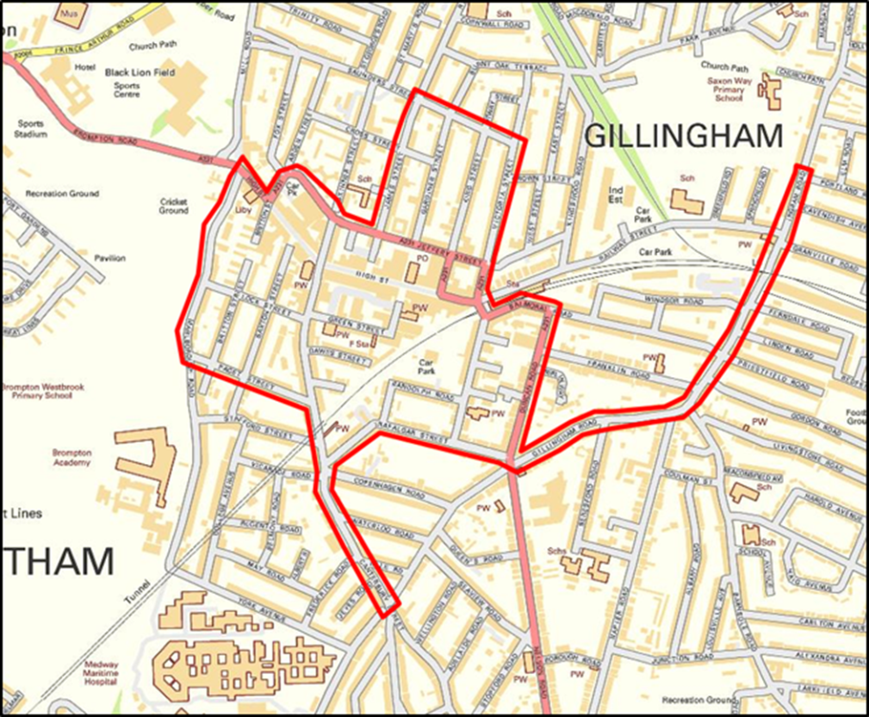

- Addresses on both sides of all roads shown in the above map are included in the CIP unless otherwise stated.

- While every effort has been made to include all roads within the above CIP area, there may be omissions, errors or additions due to ongoing development, and the following list is only intended as a guide. The area delineated above is the area covered by the CIP and it is the applicant’s responsibility to confirm the location of their premises.

List of roads included in the Gillingham High Street CIP

A231 from Jeffrey St to Duncan Rd
Balmoral Rd from Duncan Rd to Trafalgar St
Britton St
Canterbury St from Skinner St to junction with Gillingham Rd
Connaught Rd
Cross St between James St and Gardiner St
Dawes St
Duncan Rd
Edinburgh Rd
Gardiner St to the junction with Saunders St
Gillingham Rd from Ingram Rd to Nelson Rd
Green St
High St,
Ingram Rd from Cavendish Ave to Gillingham Rd
James St
Jeffery St between the High St and the A231
King St
Lawrence St
Lock St
Marlborough Rd from High St to Paget St
Osborne Rd
Paget St
Randolph Rd
Saunders St
Saxton St from High St to Paget St
Skinner St from Jeffery St to Canterbury St
Theodore Pl
Trafalgar St
Victoria St

Cumulative Impact Policy 3 - Luton Road and Chatham Central area

Evidence summary

- The Luton and Wayfield and Chatham Central wards suffer from widespread multiple deprivation. There are areas within these wards that are some of the most deprived for crime deprivation in the country.

- Evidence shows this CIP area has unacceptably high rates of:

  - Alcohol related crime and disorder, with Luton Road and surrounding areas showing as a hot spot for the following:
    - anti-social behaviour
    - domestic abuse
    - criminal damage
  - Alcohol related hospital admissions:
    - Luton and Wayfield and Chatham Central wards have some of the highest rates of alcohol related hospital admissions.
  - Alcohol related ambulance callouts:
    - Luton and Wayfield and Chatham Central are in the top 6 wards in Medway from 2011 onwards for ambulance callouts where alcohol has been deemed to be a contributory factor.
  - Luton Road and surrounding areas have particular problems with street drinking and associated nuisance, such as intimidating behaviour, litter and public urination and defecation.

- The Community Safety Unit identified issues around the availability and consumption of high-strength cheap beer and cider linked to health issues, public nuisance, anti-social behaviour and crime.

- A majority of respondents to a community questionnaire felt licensed premises in this area contribute towards alcohol related issues, and that customers from licensed premises contribute to problems of public nuisance and issues with children. Off licensed premises were identified by all respondents as contributing to alcohol related problems.

- The evidence highlighting the harms was first considered by the Licensing and Safety Committee on the 8th March 2017. This evidence has been superseded following a review of the Cumulative Impact Assessment (CIA) This fresh evidence supporting the continuation of the policy can be found at Link to current CIA from police and Public Health

- Cumulative Impact Policy 3 will apply to the following applications for the sale of alcohol for consumption off the premises.

  - New premises licence applications
  - Material variations for existing premises licences
  - Provisional statements for premises licences

Luton Road and Chatham Central area overview and policy aims

- This is a densely populated area of Medway with many houses of multiple occupation, poor quality housing stock and many social and health issues.

- There has been a growth of off licensed premises in the CIP, and surrounding area, all of which are small convenience stores, corner shops and newsagents. The general availability of alcohol, including the products known as ‘super strength’ beer and cider i.e. cheap beer and cider products over 5.5%ABV, is a real concern. The number of premises makes cheap alcohol, particularly high-strength products, readily available. Responsible authorities, other agencies and residents in the area have provided evidence showing the number of off licensed premises has led, in part, to issues of street drinking and associated crime, disorder and nuisance as well as other, more hidden alcohol related harms, such as domestic abuse and health harms. Where its discretion is engaged the Authority regards the prevention of public nuisance, crime and disorder affecting residents as a material consideration in any application.

- Residents have expressed their aspirations for the area in terms of an improved mix of retail businesses which do not rely on the sale of alcohol, including access to affordable fresh food and groceries and good quality cafés. They have also expressed a wish to see a good use of community space, both indoors and outside, with heritage properties restored and well used.

- Notwithstanding the existence of the CIP, the Authority is supportive of applications which will positively benefit this area in line with the aspirations outlined above. The key aim in Luton and Chatham Central is to encourage and expand the local retail and community offer, with the intention of providing venues which are attractive to all age groups and a diversity of licensed premises primarily for use in the day time economy:
  - Cafés, with an emphasis on good quality, family friendly venues
  - Community and arts venues
  - Venues which complement and enhance Medway’s heritage
  - Premises where the sale of alcohol is ancillary to the main business

Luton Road and Chatham Central CIP area map

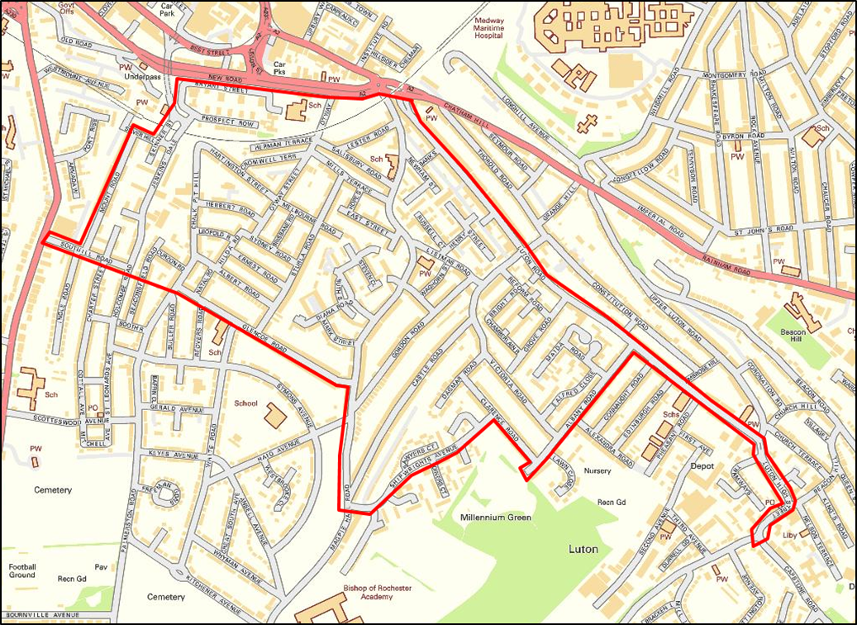

- Addresses on both sides of all roads shown in the above map are included in the CIP unless otherwise stated.

- While every effort has been made to include all roads within the above CIP area, there may be omissions, errors or additions due to ongoing development, and the following list is only intended as a guide. The area delineated above is the area covered by the CIP and it is the applicant’s responsibility to confirm the location of their premises.

List of roads included in the Luton Road and Chatham Central CIP

Albany Rd
Albert Rd
Alfred Cl
Bank St
Beaconsfield Rd from footpath to Holcombe Rd to Curzon Rd
Bryant St
Castle Rd
Chalk Pit Hill
Charter St between Warner St and Southill Rd
Christopher Cl
Claremont Way
Clarence Rd
Cromwell Terrace
Curzon Rd
Diana Rd
East St
Edward St
Ernest Rd
Glencoe Rd
Gordon Rd
Hannah Cl
Hare St
Hartington St
Henry St
Herbert Rd
Herman Terrace
Holcombe Rd between Jenkin’s Dale to Southill Rd
Hope St
Jenkin’s Dale
Leopold Rd
Lester Rd
Listmas Rd
Luton High St
Luton Rd
Magpie Hall Rd between the A2 and Shipwrights Ave
Maida Rd
Mark St
Mary Ct
Mills Terrace
Mount Rd
Natal Rd
Newnham St
Oliver Cl
Otway St
Otway Terrace
Palmerston Rd from Albert Rd to Glencoe Rd
Portland St
Prospect Row
Russell Ct
Ruth St
Salisbury Rd
Sawyers Cl
Shipwrights Ave
Short St
Silver Hill
Skinner St
Southill Rd
Stevens Cl
Sturla Rd
Sydney Rd
Victoria Rd
Waghorn St
Warner St

Cumulative Impact Policy 4 - Rochester High Street

Evidence summary

- Rochester High Street and the surrounding area is not the most deprived part of Medway, but for crime deprivation it ranks as 530 nationally, out of 32 844 areas, where 1 is the most deprived.

- Evidence shows this area has unacceptably high rates of:

  - Alcohol related crime and disorder, with Rochester High Street and surrounding areas showing as a hot spot for the following:
    - anti-social behaviour
    - assaults
    - arrests for:
    - drunk and disorderly
    - public order
    - domestic abuse
  - Alcohol related hospital admissions:
    - part of Rochester East ward, known as Troy Town, has some of the highest rates of alcohol related hospital admissions
  - Alcohol related ambulance callouts:
    - Rochester East and West wards have been in the top 8 wards in Medway between 2011 and 2015 for ambulance callouts identified as having alcohol as a contributory factor.
  - Medway Hospital A&E assault data:
    - Rochester High Street is shown as a hot spot for assaults reported by persons attending Medway A&E.
  - Rochester High Street and surrounding areas have problems with street drinking and associated nuisance, such as begging, intimidating behaviour, litter and public urination and defecating.

- The Community Safety Unit identified issues around the availability and consumption of high-strength cheap beer and cider linked to health issues, public nuisance, anti-social behaviour and crime. Rochester High St has been identified as the main focus of partnership activity for tackling anti-social behaviour relating to the night-time economy.

- The majority of respondents to a community questionnaire felt licensed premises in this area contribute towards alcohol related issues. The main concerns were with alcohol related crime and disorder and public nuisance. The main focus was on the night-time economy, although problems were identified with begging and intimidating behaviour of street drinkers during the day. The majority identified pubs/bars and nightclubs as being associated with the most problems, followed by off licences. The majority of respondents felt the number of licensed premises in the area contribute to alcohol related problems.
- The evidence highlighting the harms was first considered by the Licensing and Safety Committee on the 8th March 2017. This evidence has been superseded following a review of the Cumulative Impact Assessment (CIA) This fresh evidence supporting the continuation of the policy can be found at Link to current CIA from police and Public Health
- Cumulative Impact Policy 4 will apply to the following applications for the sale of alcohol for consumption off the premises.

  - New premises licence applications
  - Material variations for existing premises licences
  - Provisional statements for premises licences

Rochester High Street area overview and policy aims

- Rochester is unique due to its historic setting. It is the location of extensive heritage assets, such as Rochester Cathedral, Rochester Castle and The Guildhall. As a result it attracts many tourists, visitors and business travellers and the Authority wants to support and encourage businesses which complement and support these assets, increasing dwell time, growing local spend and improving the economic health of the city centre.

- Rochester High Street is also a mixed use area, with many residential, as well as commercial, properties. There are nearly 500 residents who live in the High Street and the roads, streets and alleyways linking the city centre to the nearby residential areas.

- The offer in the High Street has evolved to support the historic attractions through the provision of commercial leisure (restaurants and cafés), reinforcing its attractiveness for day and evening activities. There are several pubs and late-night venues and it has the primary late-night economy in Medway.

- There are also several off licences, all of which are small convenience stores, corner shops and newsagents. Many of these sell products which are termed as ‘super strength’ beer and cider i.e. cheap beer and cider products over 5.5% ABV, making cheap, high-strength alcohol readily available. Responsible authorities, other agencies, residents and businesses in Rochester have provided evidence showing the number of off licensed premises has led, in part, to issues of street drinking and associated crime, disorder and nuisance as well as other, more hidden alcohol related harms, such as domestic abuse and health harms. Kent Police and Rochester residents have evidenced alcohol related crime, disorder and nuisance associated with both day time alcohol misuse and the night-time economy.

- A new railway station has been built, creating a sense of arrival for visitors, improving transport links and further supporting Rochester, and Medway, as a leisure destination focussed around its heritage assets.

- Rochester Riverside, just outside the CIP area, situated between the river and Corporation Street, will provide a quality waterfront location for homes, leisure, jobs and services, complementing and respecting the unique historic High Street.

- Rochester has an established reputation for street festivals in the High Street area, such as the Sweeps Festival and the Dickens Festival, as well as open air concerts and events in the Castle grounds. There is also an award winning visitors’ centre and extensive parking.

- There is potential to increase both visitor numbers and local engagement and raise Medway’s image as a tourist destination by enhancing and strengthening the above offer by encouraging a range of diverse venues and promoting hotel development to ensure Medway becomes a strong weekend break destination. A successful Rochester High Street should provide a range of accessible services and facilities and also contribute to the image of Medway, as the place which many visitors first see when they arrive in the area.

- Notwithstanding the existence of the CIP, members are supportive of applications which will positively benefit the High Street in line with the aspirations outlined above. The kind of applications which would be encouraged are family friendly venues, such as restaurants, community venues and other leisure businesses where the sale of alcohol is ancillary to the main activity.

- The key aim in Rochester High Street is to encourage and expand the leisure, tourism and business visitor offer, with the intention of providing premises attractive to all age groups and a diversity of licensed premises primarily centred on the day and early evening economy including:
  - Restaurants and cafés, with an emphasis on good quality, family friendly venues
  - Premises where the sale of alcohol is ancillary to the main business, such as:
  - Exhibition and art venues
  - Theatres and cinemas
  - Hotels
  - Venues which complement and enhance Medway’s heritage

- This is a less restrictive approach than is suggested in the Statutory Guidance, which suggests that licensing authorities can adopt a policy of refusing all new licences in areas where special policies on cumulative impact apply, subject to their discretion being engaged.

Rochester High St CIP area map
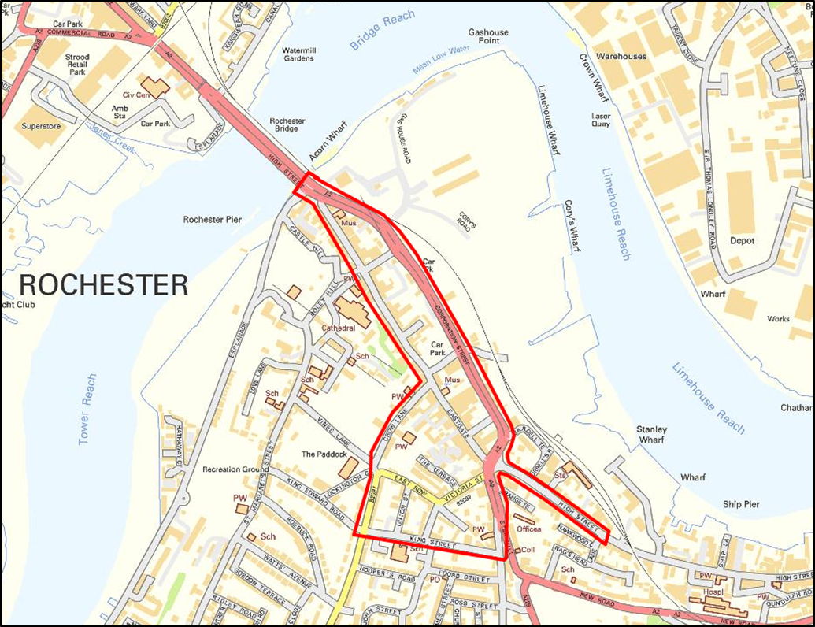

- Addresses on both sides of all roads shown in the above map are included in the CIP unless otherwise stated.

- While every effort has been made to include all roads within the above CIP area, there may be omissions, errors or additions due to ongoing development, and the following list is only intended as a guide. The area delineated above is the area covered by the CIP and it is the applicant’s responsibility to confirm the location of their premises.

List of roads included in the Rochester High Street CIP
Almon Place
Bishops Walk
Blue Boar Lane
Cazeneuve St
Corporation St
Crow Lane
Davey Ct
East Row
Eastgate
Eastgate Terrace
Gravel Walk
High St to the junction with Nags Head Lane
La Providence
Maidstone Rd from East Row to King St
Northgate
Star Hill from Corporation St to King St
The Terrace
Union St
Victoria St

Stress Area Policy 1 - Strood Town Centre Stress area

Evidence summary

- This area is not the most deprived area in Medway but has significant rates for crime deprivation.

- Evidence shows this area has concerning rates of:

  - Alcohol related crime and disorder, with Strood Town Centre and surrounding areas having issues with the following:
    - anti-social behaviour
    - assaults
    - criminal damage
    - domestic abuse
  - Alcohol related hospital admissions:
    - Strood North ward has some of the highest rates of alcohol related hospital admissions in Medway
  - Alcohol related ambulance callouts:
    - Strood North ward has been in the top 7 or 8 wards in Medway for the number of ambulance callouts where alcohol has been deemed to be a contributory factor
  - Strood town centre has problems with street drinking and associated nuisance, such as begging, intimidating behaviour, litter and public urination and defecating.

- The Community Safety Unit identified issues around the availability and consumption of high-strength cheap beer and cider linked to health issues, public nuisance, anti-social behaviour and crime.

- The evidence highlighting the harms was first considered by the Licensing and Safety Committee on the 8th March 2017. This evidence has been superseded following a review of the Cumulative Impact Assessment (CIA) This fresh evidence supporting the continuation of the policy can be found at Link to current CIA from police and Public Health

- Stress Area Policy 1 will apply to the following applications for the sale of alcohol for consumption off the premises.

  - New premises licence applications
  - Material variations for existing premises licences
  - Provisional statements for premises licences

Strood Town Centre overview and policy aims

- The evidence and policy aims of CIP 4 are relevant to this policy document, and should be read in conjunction with it. Pedestrians using Rochester Bridge linking Rochester city centre and Strood town centre take a few minutes’ walk to walk between the two, and alcohol can easily be purchased in one area and consumed in the other. This makes the issues of dispersal and displacement from one area to the other a concern for the Authority.

- Strood acts as a gateway to Medway but is primarily a convenience retail destination with a strong local function, with Strood Retail Park, and the district centre around a traditional High Street serving the local community. Although it provides everyday basic needs, the general quality of the town centre environment is currently poor.

- Both Strood Riverside and Temple Waterfront development sites are close to Strood Town Centre and it is intended, in Medway’s regeneration policies, these will be established as areas for both employment and residential use. Strood town centre will be within easy walking distance of both developments.

- There is currently little leisure provision in this area.

- Rochester, which has developed a number of niche markets around arts and tourist related uses, is located within a 5 to 10 minutes’ walk of Strood town centre. This area is characterised by a high proportion of pubs, bars and restaurants and it has a vibrant evening economy. There is a CIP in place for Rochester City Centre and the Authority has concerns around the dispersal and displacement of alcohol related issues between the two centres.

- In Medway it has been identified that local centres are valued by communities for a range of retail services and community facilities, such as libraries. The Authority supports the social dimension of sustainable development by ensuring local services reflect the community’s needs, and it wants to support a strategy in Strood town centre which sees a high quality built environment supporting the local community by providing a strong and healthy town centre.

- Notwithstanding the existence of the stress area policy, members are supportive of applications which will positively benefit Strood town centre in line with the aspirations outlined above and will not add to the alcohol related harms outlined in the evidence which gave rise to this policy.

Suggested measures

- As outlined in the Statutory Guidance the Authority recommends that applicants complete a risk assessment of their business in order to understand what steps are required to complete the operating schedule in a manner which enables the Council, responsible authorities and other persons to assess how they will seek to promote the licensing objectives in this area. Risk assessments will vary according to the nature of the business, and it is for applicants to decide what is appropriate in each case.

- The risk assessment should contain many of the key factors which the responsible authorities will be expecting applicants to meet in order to fulfil the licensing objectives. The risk assessment approach will reduce the possibilities of representations.

- The Authority recognises that it cannot insist on a risk assessment. However an applicant who decides not to complete or provide a risk assessment may face representations and the expense of hearings as a result. If a risk assessment is not completed then applicants will need to demonstrate how these matters have been addressed through the operating schedule provided.

- While it is a matter for each applicant, the Authority strongly recommends that all issues identified in this and the surrounding area are addressed when completing their risk assessment.

- The Authority, having accepted the evidence of alcohol related problems in this area, encourages applicants for the sale of alcohol off the premises to consider the following measures:

  - Hours of operation:
  - off licensed premises 0900–2300
  - Installation of CCTV to a standard acceptable to Kent Police
  - Challenge 25 policy
  - Documented refusals system
  - Documented staff training, and retraining, including under age sales, proxy sales and drunkenness
  - Minimum staffing levels
  - Membership of the Safer Medway Partnership
  - Restrictions on high-strength beers, lagers and ciders
  - A clear glazing policy to allow for a clear and unobstructed view to the front of the premises
  - No sale of single cans or bottles of beer, lager or cider
  - Defined display areas
  - Monitoring of litter in immediate area

Strood stress area map

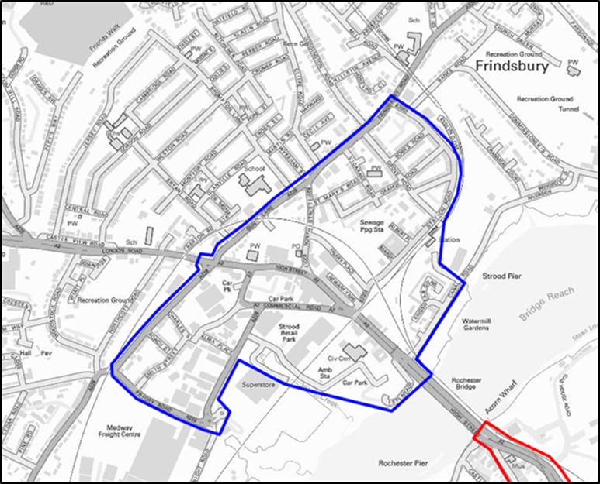

- Addresses on both sides of all roads shown in the above map are included in the SAP unless otherwise stated.

- While every effort has been made to include all roads within the above SAP area, there may be omissions, errors or additions due to ongoing development, and the following list is only intended as a guide. The area delineated above is the area covered by the SAP and it is the applicant’s responsibility to confirm the location of their premises.

List of roads included in the Strood Town Centre SAP.

Albert Place
Alma Place
Bowes Road
Burgess Road
Canal Road
Charles Street
Commercial Road
Cuxton Road between Gun Lane and Priory Road
Doggett’s Square
Edward Street
Esplanade
Frindsbury Road between Station Road and North Street
Friary Place
Grange Road
Grove Road
Gun Lane
High St between Rochester Bridge and Gun Lane/Cuxton Road
Knight Road
Marsh Street
Newark Yard
North Street
Priory Road
Roach Street
Smith Street
South Eastern Road
St Mary’s Road
Station Road
Vicarage Road
Victoria Street

Stress Area Policy 2 - Chatham High Street, Rochester High Street and A2 Stress area

Evidence summary

- This is one of the most deprived areas in Medway.

- Evidence shows this area has concerning rates of:

  - Alcohol related crime and disorder, with both Chatham and Rochester, and surrounding areas, having issues with the following:
    - anti-social behaviour
    - assaults
    - criminal damage
    - public order
    - sexual offences
  - Alcohol related hospital admissions:
    - River ward has some of the highest rates of alcohol related hospital admissions in Medway
  - Alcohol related ambulance callouts:
    - River ward has had the highest number of ambulance callouts where alcohol has been deemed to be a contributory factor, in Medway since 2011.

- Both Chatham and Rochester High Streets, and this connecting ‘corridor’ between the two, have problems with street drinking and associated nuisance, such as begging, intimidating behaviour, litter and public urination and defecating.

- The Community Safety Unit identified issues around the availability and consumption of high-strength cheap beer and cider linked to health issues, public nuisance, anti-social behaviour and crime.

- In Chatham all respondents to a community questionnaire felt licensed premises in this area contribute towards alcohol related issues, and that customers from licensed premises contribute to problems of public nuisance and public safety. The majority identified off licences as the main concern, followed by pubs and bars. All respondents felt the number of licensed premises in the area contribute to alcohol related problems.

- In Rochester the majority of respondents to a community questionnaire felt licensed premises in this area contribute towards alcohol related issues. The main concerns were with alcohol related crime and disorder and public nuisance. The main focus was on the night-time economy, although problems were identified with begging and intimidating behaviour of street drinkers during the day. The majority identified pubs/bars and nightclubs as being associated with the most problems, followed by off licences. The majority of respondents felt the number of licensed premises in the area contribute to alcohol related problems.

- The evidence highlighting the harms was first considered by the Licensing and Safety Committee on the 8th March 2017. This evidence has been superseded following a review of the Cumulative Impact Assessment (CIA) This fresh evidence supporting the continuation of the policy can be found at Link to current CIA from police and Public Health
- Stress Area Policy 2 will apply to the following applications for the sale of alcohol for consumption off the premises.

  - New premises licence applications
  - Material variations for existing premises licences
  - Provisional statements for premises licences

Area overview and policy aims

- The evidence and policy aims of CIP 1 and CIP 4 are relevant to this policy document, and should be read in conjunction with it, as this area acts as a ‘corridor’ between Rochester and Chatham High Streets. Pedestrians are able to walk between the two centres in 10 to 15 minutes. The A2, which runs parallel to the High Street, is similar.

- There are several cafés and restaurants along this section of the High Street, as well as several ‘micropubs’ and larger, more traditional, public houses. Along the A2 there is a night club, fitness and health club with a bar and a hotel. There are no off licences in the defined area.

- This is a mixed use area, with residential properties as well as business and retail outlets. Where its discretion is engaged the Authority regards the prevention of public nuisance, crime and disorder to residents as a material consideration in any application.

- Communities value a range of retail and leisure services and community facilities. The Authority wants to ensure local services reflect the community’s needs, and to support a strategy which sees a strong, vibrant and healthy community.

- Notwithstanding the existence of the stress area policy, members are supportive of applications which will positively benefit the area between Rochester and Chatham in line with the aspirations outlined above.

Suggested measures

- As outlined in the Statutory Guidance the Authority recommends that applicants complete a risk assessment of their business in order to understand what steps are required to complete the operating schedule in a manner which enables the Council, responsible authorities and other persons to assess how they will seek to promote the licensing objectives. Risk assessments will vary according to the nature of the business, and it is for applicants to decide what is appropriate in each case.

- The risk assessment should contain many of the key factors which the responsible authorities will be expecting applicants to meet in order to fulfil the licensing objectives. The risk assessment approach will reduce the possibilities of representations.

- The Authority recognises that it cannot insist on a risk assessment. However an applicant who decides not to complete or provide a risk assessment may face representations and the expense of hearings as a result. If a risk assessment is not completed then applicants will need to demonstrate how these matters have been addressed through the operating schedule provided.

- While it is a matter for each applicant, the Authority strongly recommends that all issues identified in this and the surrounding area highlighted in the evidence at the above link is addressed when completing their risk assessment.

- The Authority, having accepted the evidence of alcohol related problems in this area, encourages applicants for the sale of alcohol for consumption off the premises to consider the following measures.

  - Hours of operation
    - Off licensed premises 0900-2300
  - Off licenced premises:
    - installation of CCTV to a standard acceptable to Kent Police
    - challenge 25 policy
    - documented refusals system
    - documented staff training, and retraining, including underage sales, proxy sales and drunkenness
    - membership of the Safer Medway Partnership
    - minimum staffing levels
    - restrictions on high-strength beers, lagers and ciders, with no sales above 5.5%ABV
    - a clear glazing policy to the front of the premises to allow for a clear and unobstructed view to the street
    - no sale of single cans of beer, lager or cider
    - defined display areas
    - monitoring of litter in immediate area

Chatham High Street, Rochester High Street and A2 stress area map

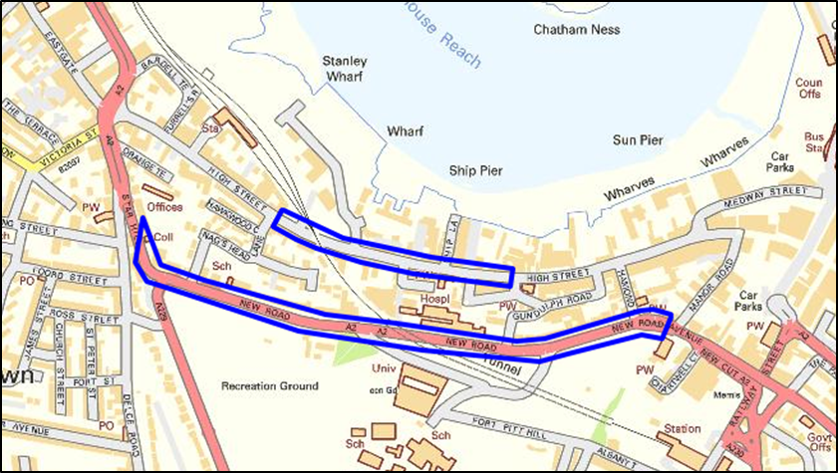

- Addresses on both sides of all roads shown in the above map are included in the SAP unless otherwise stated.

- While every effort has been made to include all roads within the above SAP area, there may be omissions, errors or additions due to ongoing development, and the following list is only intended as a guide. The area delineated above is the area covered by the SAP and it is the applicant’s responsibility to confirm the location of their premises.

List of roads included in the Chatham High Street, Rochester High Street and A2 Stress area.

High Street between Gundulph Road and Nags Head Lane
A2, New Road between Manor Road and Star Hill

Stress Area Policy 3 - Gillingham South Stress area

Evidence summary

- This is one of the most deprived areas in Medway.

- Evidence shows this area has concerning rates of:
  - Alcohol related crime and disorder, with Gillingham High St and Canterbury St having issues with the following:
    - anti-social behaviour
    - criminal damage
    - public order
    - sexual offences
    - domestic Abuse
  - Alcohol related hospital admissions
  - Alcohol related ambulance callouts:
    - since 2012 Gillingham South has had the second highest number of ambulance callouts where alcohol has been deemed to be a contributory factor.

- The Community Safety Unit identified issues around the availability and consumption of high-strength cheap beer and cider linked to health issues, public nuisance, anti-social behaviour and crime.
- The evidence highlighting the harms was first considered by the Licensing and Safety Committee on the 8th March 2017. This evidence has been superseded following a review of the Cumulative Impact Assessment (CIA) This fresh evidence supporting the continuation of the policy can be found at Link to current CIA from police and Public Health
- Stress Area Policy 3 will apply to the following applications for the sale of alcohol for consumption off the premises.

  - New premises licence applications
  - Material variations for existing premises licences
  - Provisional statements for premises licences

Area overview and policy aims

- The evidence and policy aims of CIP 2 are relevant to this policy document, and should be read in conjunction with it, as this area is immediately to the south of the Gillingham CIP area, with some of the CIP area extending into the SAP area. This makes the issue of dispersal and displacement a material concern for the Authority.

- There has been a growth of off licensed premises in Gillingham, most of which are small convenience stores, corner shops and newsagents. Gillingham High Street and surrounding area has the highest concentration of off licenced premises in Medway. Many of these sell products which are termed as ‘super strength’ beer and cider i.e. cheap beer and cider products over 5.5% ABV, making cheap, high-strength alcohol readily available. Responsible authorities, other agencies, residents and businesses in Gillingham have provided evidence showing the number of off licensed premises has led, in part, to issues of street drinking and associated crime, disorder and nuisance as well as other, more hidden alcohol related harms, such as domestic abuse and health harms.

- This is predominately a residential area with the policy boundary running around the perimeter of the hospital. Where its discretion is engaged the Authority regards the prevention of public nuisance, crime and disorder to residents as a material consideration in any application.

- Communities value a range of retail and community facilities. The Authority wants to ensure local services reflect the community’s needs, and to support a strategy which sees a strong and healthy retail offer.

- Notwithstanding the existence of the stress area policy, members are supportive of applications which will positively benefit the area in Gillingham South.

Issues to address

- As outlined in the Statutory Guidance the Authority recommends that applicants complete a risk assessment of their business in order to understand what steps are required to complete the operating schedule in a manner which enables the Council, responsible authorities and other persons to assess how they will seek to promote the licensing objectives. Risk assessments will vary according to the nature of the business, and it is for applicants to decide what is appropriate in each case.

- The risk assessment should contain many of the key factors which the responsible authorities will be expecting applicants to meet in order to fulfil the licensing objectives. The risk assessment approach will reduce the possibilities of representations.

- The Authority recognises that it cannot insist on a risk assessment. However an applicant who decides not to complete or provide a risk assessment may face representations and the expense of hearings as a result. If a risk assessment is not completed then applicants will need to demonstrate how these matters have been addressed through the operating schedule provided.

- While it is a matter for each applicant, the Authority strongly recommends that all issues identified in this and the surrounding area highlighted in the evidence at the above link is addressed when completing their risk assessment.

- The Authority, having accepted the evidence of alcohol related problems in this area, encourages applicants for the sale of alcohol for consumption off the premises to consider the following measures.

  - Hours of operation:
    - off licensed premises 0900 – 2300
  - Installation of CCTV to a standard acceptable to Kent Police
  - Challenge 25 policy
  - Documented refusals procedure
  - Documented staff training, and retraining, including under age sales, proxy sales and drunkenness
  - Membership of the Safer Medway Partnership
  - Restrictions on high-strength beers, lagers and ciders, with no sales above 5.5% ABV
  - A clear glazing policy to the front of the premises to allow for a clear and unobstructed view to the street
  - No sale of single cans of beer, lager or cider
  - Defined display areas
  - Monitor litter in the immediate area

Gillingham South stress area map

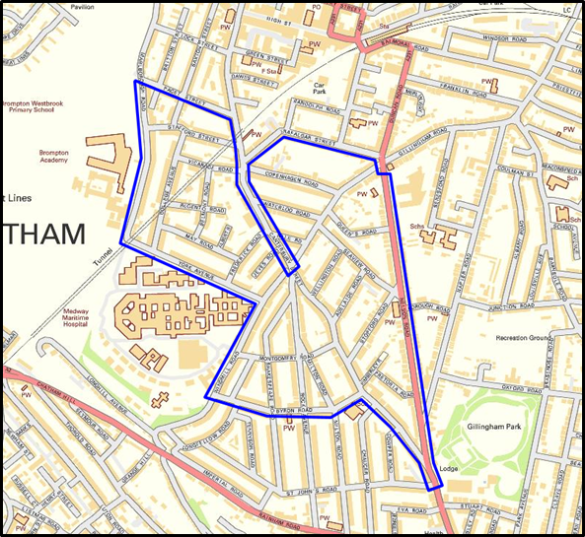

- Addresses on both sides of all roads shown in the above map are included in the CIP unless otherwise stated.

- While every effort has been made to include all roads within the above CIP area, there may be omissions, errors or additions due to ongoing development, and the following list is only intended as a guide. The area delineated above is the area covered by the CIP and it is the applicant’s responsibility to confirm the location of their premises.

List of roads included in the Gillingham South SAP area.

Adelaide Road
Albert Road
Belmont Road
Britton Street south of Paget Street
Byron Road
Canterbury Street from Nelson Road to Rock Avenue
College Avenue
Copenhagen Road
Frederick Road
Gillingham Road from Nelson Road to Canterbury Street
Jeyes Road
Longfellow Road
Marlborough Road from York Avenue to Paget Street
May Road
Milton Road from Rock Avenue to Byron Road
Montgomery Road
Nelson Road from Gillingham Road to St John’s Road
Nile Road
Pretoria Road
Queen’s Road
Regent Road
Rock Avenue from Canterbury Street to Byron Road
Saxton Street from Stafford Street to Paget Street
Seaview Road
Shakespeare Road from Rock Avenue to Byron Road
Stopford Road
Vicarage Road
Waterloo Road
Wellington Road
Windmill Road from Canterbury Street to Byron Road
York Avenue

