Voter ID: Voting in the local elections in England on 4 May 2023

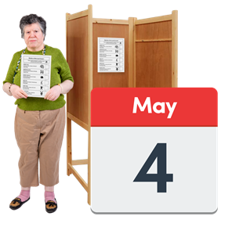
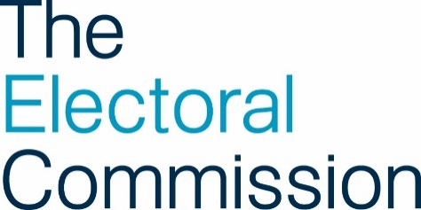
Everything you need to know about photo ID for the local elections

Contents

Introduction 2
How do I register to vote? 2
Which election am I voting in? 4
ID for voting 5
Applying for a Voter Authority Certificate 7
Voting at the polling station 11
Other ways to vote 13
More information 16
Words used in this easy read 20

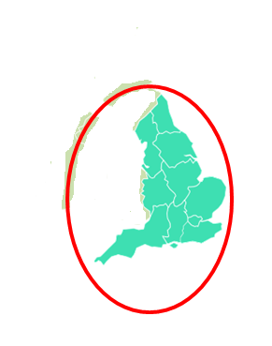
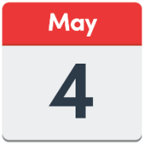
Introduction

On Thursday 4 May 2023 there will be local elections in some parts of England.

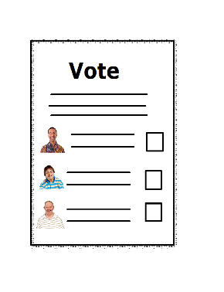
This document tells you what you need to do to be able to vote at the local elections.

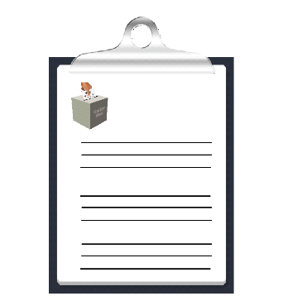
How do I register to vote?

Before you can vote in an election, you must register to vote.

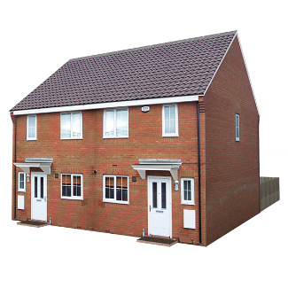

If you have moved to a different address

or changed your name since you registered
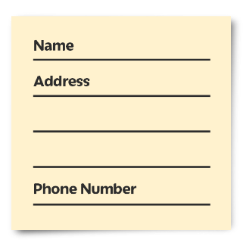
you will need to update your details.

You can register to vote, or update your details on the Government’s website (https://www.gov.uk/register-to-vote)

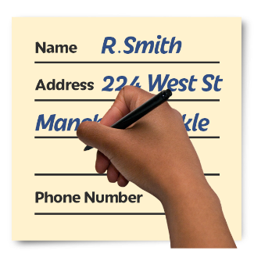

or you can fill in a paper application form.

If you:
- need help to register to vote
- need help to update your details
- or want a paper application form

contact your local council.

To find the contact details for your local council, go to the Electoral Commission’s website (https://www.electoralcommission.org.uk/voter)

or phone our helpline on 0800 328 0280.

Which election am I voting in?

Local elections are taking place in 230 councils in England on Thursday 4 May 2023.

To find out if there are elections where you live, go to the Electoral Commission’s website (https://www.electoralcommission.org.uk/voter)
or phone our helpline on 0800 328 0280.

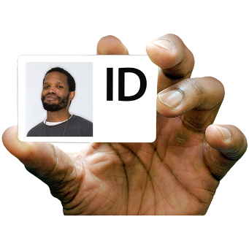
ID for voting

You will need to take photo ID with you when you vote at a polling station.

You will need to show 1 form of ID from this list:
- passport
- driving licence (a provisional licence is ok)
- identity card with PASS mark
- biometric immigration document
- defence identity card
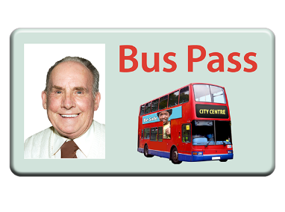

Some concessionary travel cards and some national identity cards are ok.

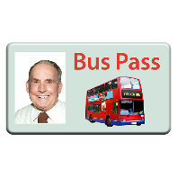
If your photo ID is out of date, it is ok to use it if the photo still looks like you.

For more information about what you can use as photo ID, go to the Electoral Commission’s website (https://www.electoralcommission.org.uk/voterID)
or phone our helpline on 0800 328 0280.
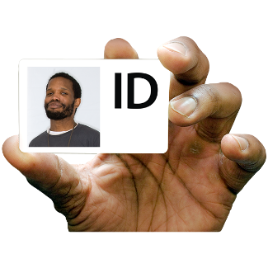
If you do not have any of the ID on the list,

or you are not sure if your photo ID still looks like you

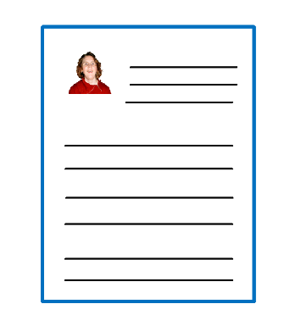

you can apply for a Voter Authority Certificate.

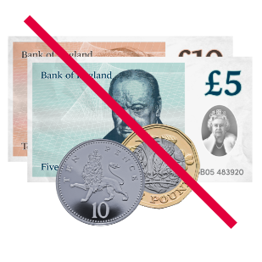
A Voter Authority Certificate is free.

You will be able to use your Voter Authority Certificate as photo ID when you vote at a polling station.

Applying for a Voter Authority Certificate

You need to be registered to vote before you can apply for a Voter Authority Certificate.
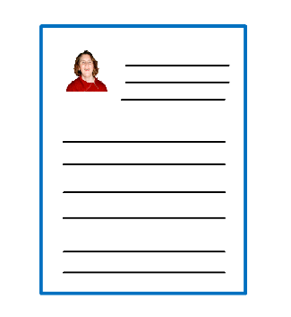

If you need a Voter Authority Certificate to vote in the elections in England on 4 May 2023,

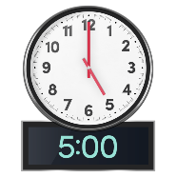
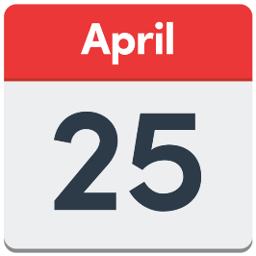
you must apply for the certificate by 5pm on Tuesday 25 April.
It is a good idea to apply as soon as possible in case your local council needs to check any details with you.

You can apply for a Voter Authority Certificate online on the Government’s website (https://www.gov.uk/apply-for-photo-id-voter-authority-certificate)
or by filling in a paper application form.

If you need help to apply for a Voter Authority Certificate, or want a paper application form

contact your local council.

To find the contact details for your local council, go to the Electoral Commission’s website (https://www.electoralcommission.org.uk/voter)
or phone our helpline on 0800 328 0280.

When you apply for your Voter Authority Certificate, you will need to know your:
- name
- address
- date of birth

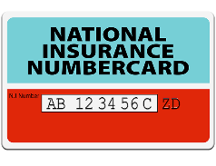
It is a good idea if you know your National Insurance Number when you apply for your Voter Authority Certificate.

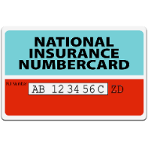
You can apply for a Voter Authority Certificate if you do not know your National Insurance Number.

If you do not know your National Insurance Number, your local council will contact you to ask for something else to prove your identity.
When you apply for a Voter Authority Certificate, you will need to send a photo with the form.

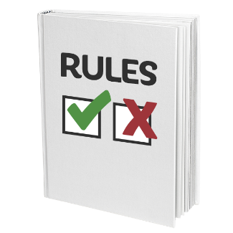
There are rules about the photo you can send.

The rules are like the rules for a passport photo.

If you do not have a photo which keeps to the rules, your local council can take a photo for you.

To find out more about the rules for the photo, go to the Electoral Commission’s website (https://www.electoralcommission.org.uk/voterID)

or phone our helpline on 0800 328 0280.

Voting at the polling station

When you arrive at the polling station, a member of staff will ask you for your name and address.

They will look for you on the voting register.

They will ask for your photo ID.

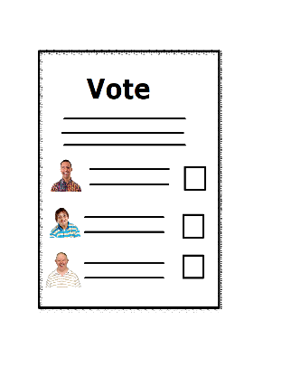

If they are happy with your photo ID, they will give you your ballot paper and let you know where you can fill it in.

There will be a private area at the polling station where staff can look at your photo ID.

If you want the staff to look at your photo ID in the private area of the polling station, let them know when you arrive at the polling station.

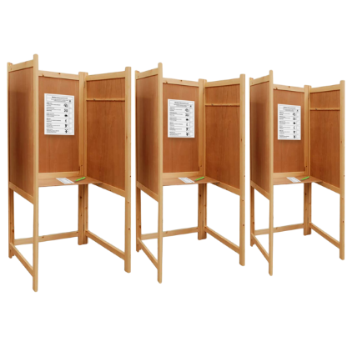
If you need any help when you are at the polling station, please ask the staff.

Other ways to vote
Voting by post
If you want to vote by post, you will need to fill in an application form.

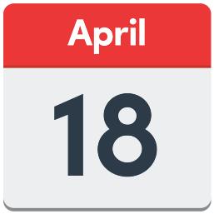
Your local council must have your form by 5pm on Tuesday 18 April 2023.

You do not need to have photo ID to vote by post.

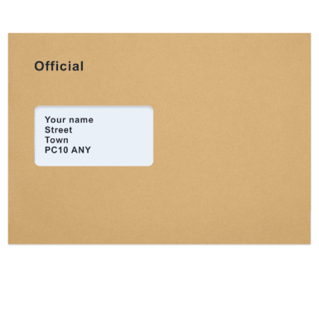

Your ballot paper will arrive in the post.

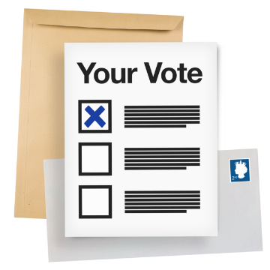
Fill in the ballot paper and send it back to your local council in your postal vote pack.

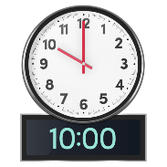
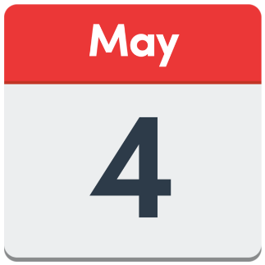
Your local council must have your postal vote pack by 10pm on Thursday 4 May.

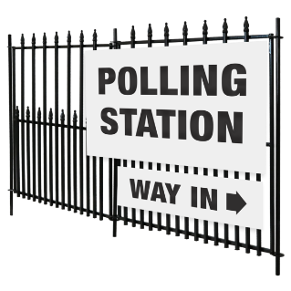
If there is not enough time to post your postal vote pack, you can take it to your polling station or local council office on Thursday 4 May.

Voting by proxy
If you want to vote by proxy, you will need to fill in an application form.

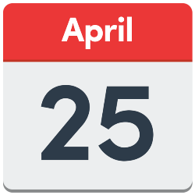
Your local council must have your form by 5pm on Tuesday 25 April 2023.

The person you choose to vote for you will need to go to your polling station to vote.

They will need to show their photo ID.

They will not need to show your photo ID to vote for you.

If you cannot go to the polling station because of an emergency, you can apply for an emergency proxy until 5pm on Thursday 4 May.

For more information, or to get a postal or proxy application form, go to the Electoral Commission’s website (https://www.electoralcommission.org.uk/voter)
or phone our helpline on 0800 328 0280.

More information

If you have any questions about:
- registering to vote
- photo ID
- how to apply for a Voter Authority Certificate
- or would like this information in a different format,

go to the Electoral Commission’s website (https://www.electoralcommission.org.uk/voter)

or phone our helpline on 0800 328 0280.

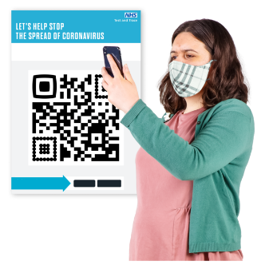
You can also scan the QR code below. The QR code will take you to the Electoral Commission website.
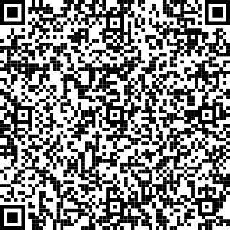

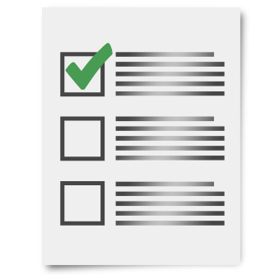
You might want to use the checklist below to check you are ready to vote in the local elections in England on Thursday 4 May 2023.

Have I registered to vote?

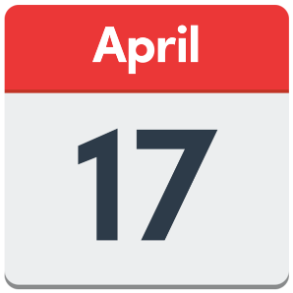
You must register to vote by 1 minute before midnight on Monday 17 April.

Do I have photo ID?

If not, have I applied for a Voter Authority Certificate?

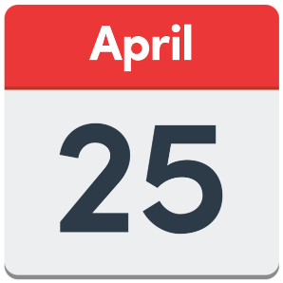
You must apply for your Voter Authority Certificate by 5pm on Tuesday 25 April.

Do I have my photo ID ready to take to the polling station with me on Thursday 4 May?

This document has been produced by the Electoral Commission.

The Electoral Commission makes sure that elections in the UK run properly.

Words used in this easy read

ballot paper the piece of paper you fill in to vote.

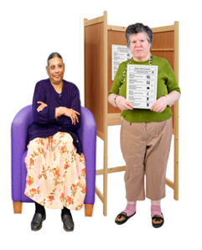
by proxy If you do something by proxy, you are doing it for someone else. If you vote by proxy, it means you ask someone you trust to vote for you.

PASS mark PASS stands for Proof of Age Standards Scheme. If an organisation has an ID card with a PASS mark, it means that the organisation has been checked. The police think the PASS mark is a good idea.

polling station The place you go to vote in an election.

Voter Authority Certificate A free document you can get to use as photo ID for voting in an election.

