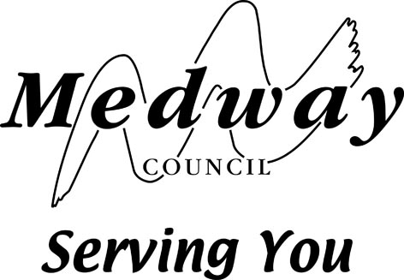


AUTHORISATION OF PROMOTER

(name of society)
is a bonafide non-commercial society duly registered under Schedule 11 of the Gambling Act 2005, for the promotion of societies lotteries as provided by Part 5 of the said Act:

The committee of the said society (being the governing body of the society) hereby authorise

(name of promoter)

of (address of promoter)

a member of the society, to act as promoter of lotteries to be held by the society.
.
APPOINTMENT OF CERTIFYING MEMBERS FOR PROMOTER’S RETURN

The committee of the said society (being the governing body of the society) hereby appoint:

(name of 1st member)

of (address of 1st member)

and (name of 2nd member)

of (address of 2nd member)

both being members of the society, of full age, for the purpose of certifying returns made by the promoter of any of the society’s lotteries.

Signed on behalf of the said committee at its meeting on the day of 20

Secretary of the society
(or other designation)

Please return to: Gravesham and Medway Shared Licensing Service, Civic Centre, Windmill Street, Gravesend, Kent DA12 1AU

